Polling Place Accessibility Supplies
Wisconsin Elections Commission
County
Municipality | City/Town/Village of  circle
Clerk/Recipient Name
Clerk/Recipient Phone Number
Shipping address
(Please no P.O. Boxes)
Address is a: | - Business/Municipal Building  What is the building called? (Ex. Town of Springfield Community Center, Bloomington City Hall, etc.) ____________________________  - Private Residence

Indicate the Quantity Needed in the Table Below
 | Item | #  Needed
 | Van-Accessible sign, 6” x 12”
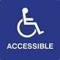 | Window Decal, 6” x 6”
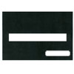 | Signature Guide, 5” x 8” total.  Typoscope cutout 5/8” x 6”  Signature cutout 1/2" x 2 ½ “
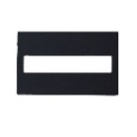 | Signature Guide, Credit Card sized, 2.12”x3.37” total
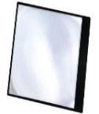 | Page Magnifier, 7” x 10”
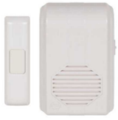 | Wireless Doorbell, Up to 500’ Range, 433 MHz
 | Cone, 12”
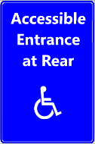 | Accessible Entrance At Rear, 12” x 18”
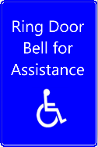 | Ring Bell for Assistance Sign, 12” x 18”
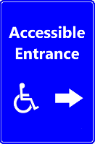 | Accessible Right Arrow Sign, 12” x 18”
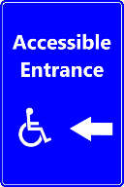 | Accessible Left Arrow Sign, 12” x 18”
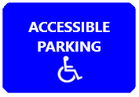 | “Regular” Accessible Parking Signs, 8” x 12”
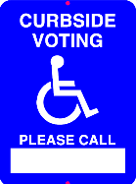 | Curbside Voting, Please Call: [ ], 9” x 12”  (Empty box for you to put a phone number in. We suggest using hardware numbers, Sharpie, etc.)
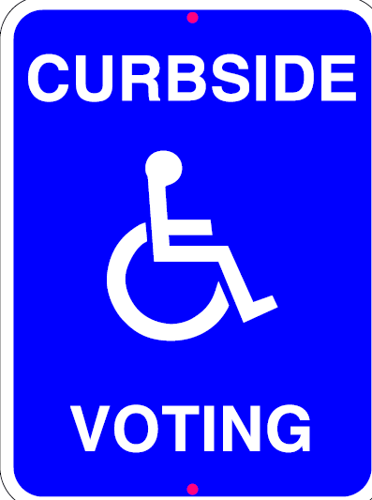 | Curbside Voting Sign (no phone number), 9” x 12”
Please send the completed form to the WEC Help Desk at elections@wi.gov or with your completed survey. Supplies are available free of charge to municipalities.

