Social media posts for use through the Spring Election on April 4
Focus of the posts – Online registration, absentee voting, general info for voters to know.
Topic | Timing | Suggested copy and image
Registration | Use on or before March 15 | Before you can vote in the Spring Election on April 4, you must be registered to vote. Do it online at MyVote.wi.gov by March 15.  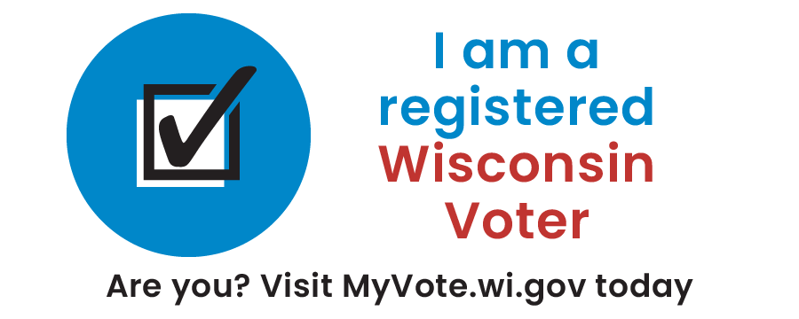
Absentee/MyVote | Use any time on or before March 23 | Requesting an absentee ballot at MyVote.wi.gov? Just confirm your name, birthdate, and address and upload your photo ID from your smartphone!  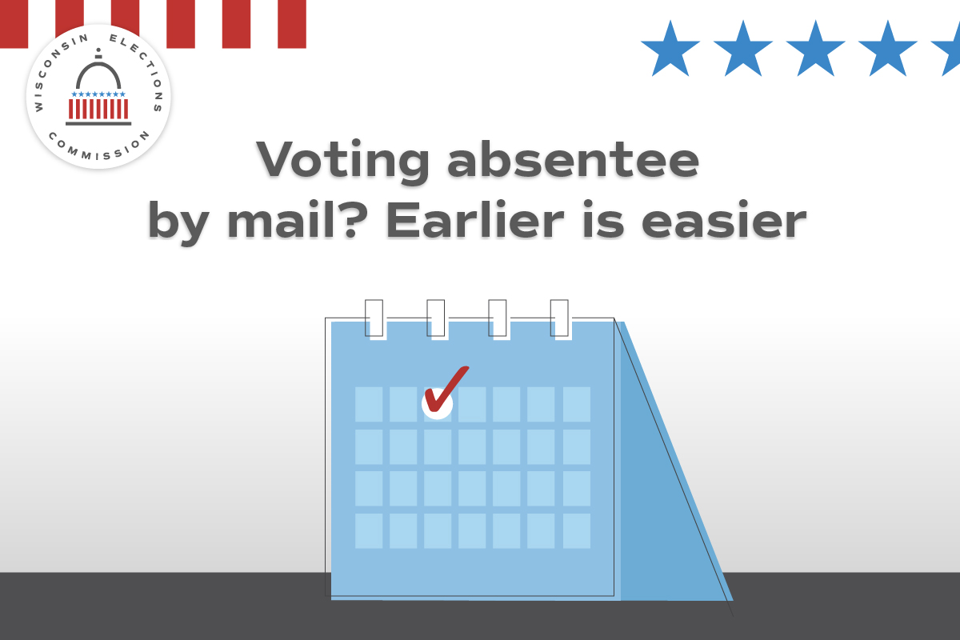
Absentee/MyVote | Use any time on or before March 23. | Registered WI voters can request an absentee by mail ballot at MyVote.wi.gov. Act now to vote at home for the April 4 Spring Election!  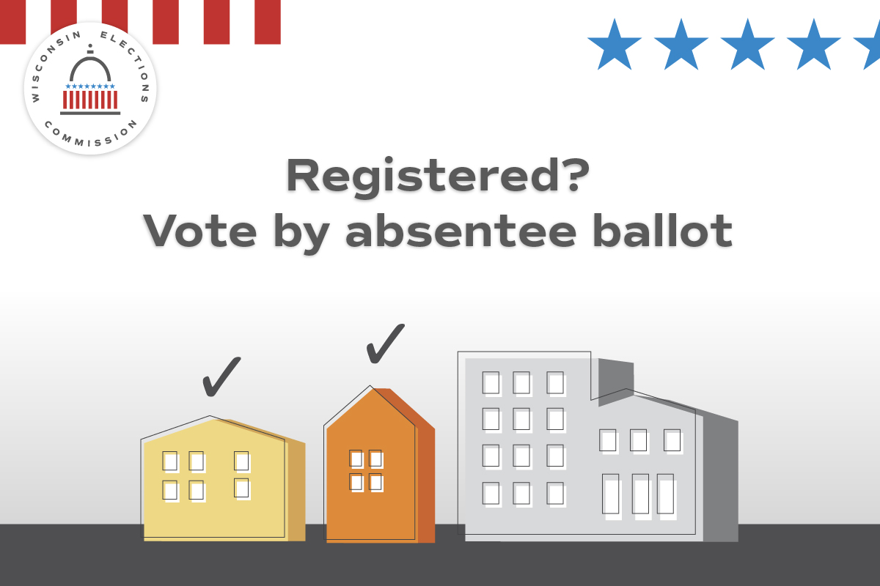
Photo ID | Use any time | Interested in getting a free ID for voting purposes? Visit https://bit.ly/free-WI-ID for more information and to get ready for April 4!  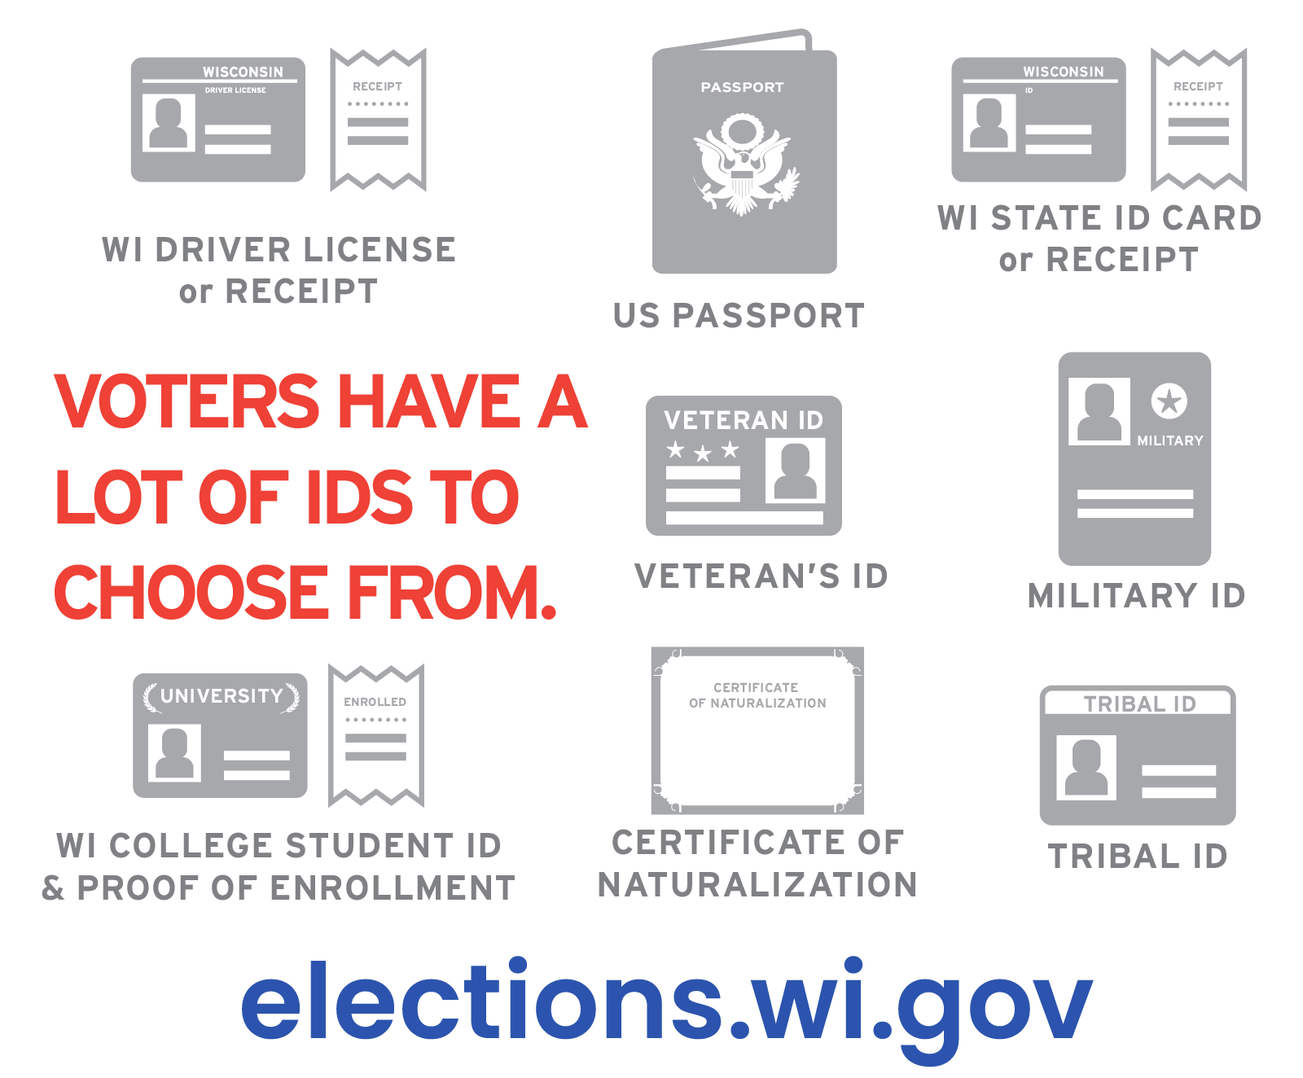
Absentee ballots | Use any time, preferably on or after March 14. | Important: If you’re voting absentee, you must mail your absentee ballot or personally deliver it to [clerk: insert drop-off locations, such as your municipal clerk’s office or designated alternate site.]  Voters who require assistance due to a disability can select someone to return the ballot.  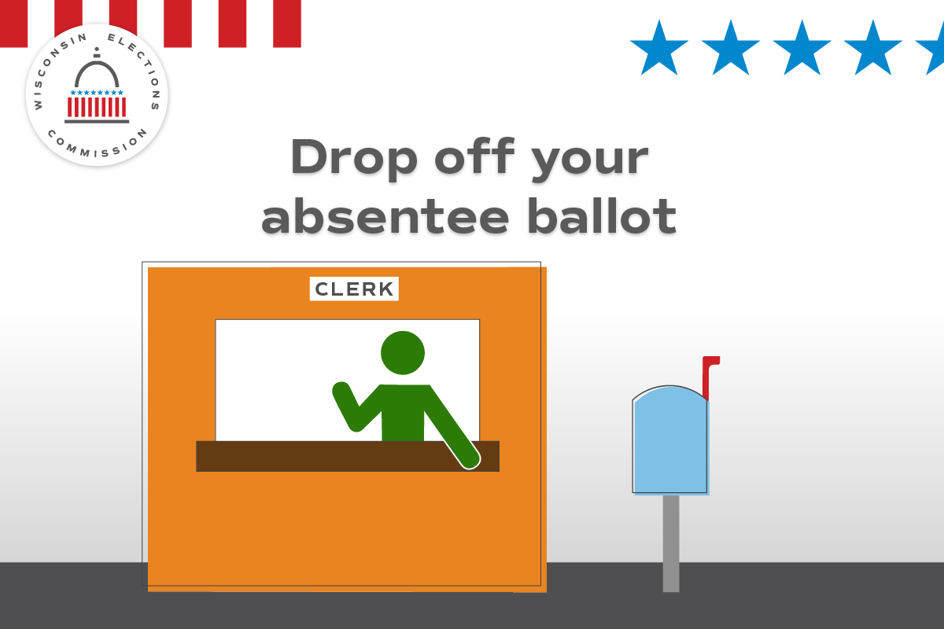
Disability rights | Use any time, preferably multiple times ahead of Election Day. | 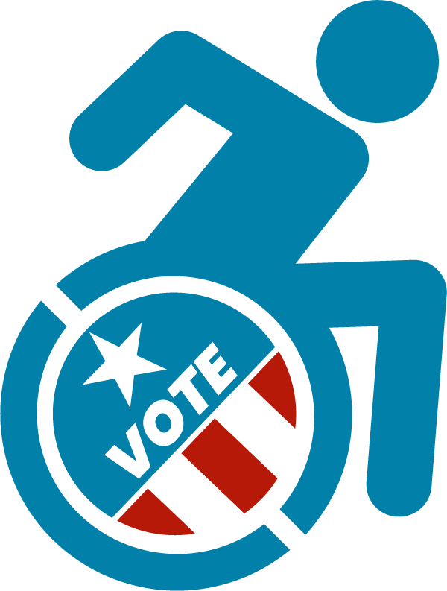  Voters who require assistance due to a disability have the right to select someone to help them with mailing or delivering their absentee ballot. Learn more at https://elections.wi.gov/memo/guidance-absentee-ballot-return-options-under-federal-voting-rights-act
Registration | Use on or before March 30 | Are you prepared for the April 4 Spring Election?  Register early if you can, either at your local clerk’s office by March 31 or at the polls on Election Day.  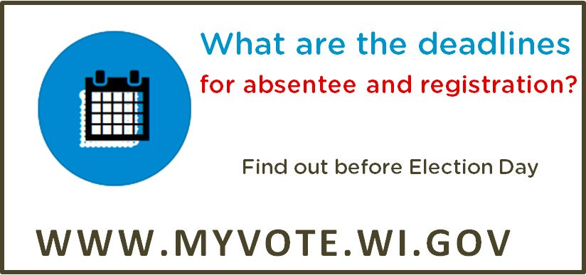

Absentee | Use any time before March 23 | Any registered voter can get their ballot mailed to them. Learn more at http://myvote.wi.gov/en-us/vote-absentee-guide  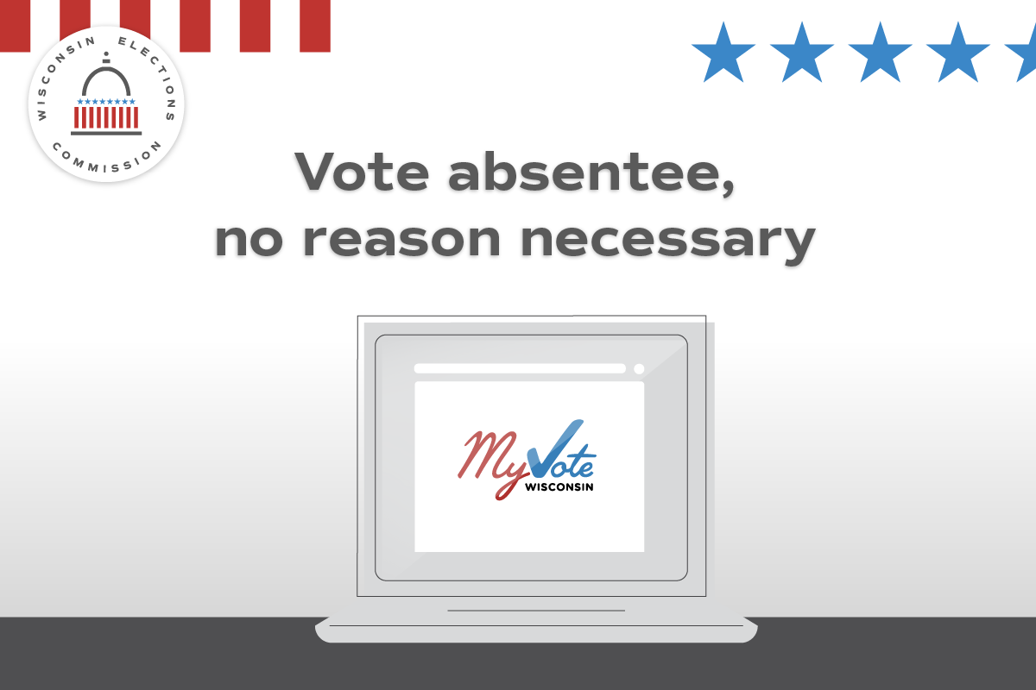
Photo ID | Use any time | Don’t have an ID for voting or documents such as a birth certificate? Get a free ID using the DMV’s ID Petition Process https://bit.ly/free-WI-ID  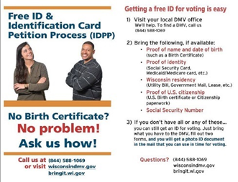
Absentee | Use on or before by March 15 | Want to vote by absentee ballot in April? Getting registered to vote or uploading a photo ID for your absentee ballot is simple at Myvote.wi.gov  The last day to register to vote online or by mail is Wednesday, March 15.
Registration | Use on or before March 15. | If you’ve moved or changed your name, you must re-register to vote. Visit MyVote.wi.gov to register online in minutes.  The last day to register to vote online is Wednesday, March 15.  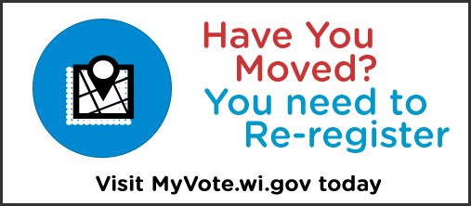
Absentee | Use any time on or before March 28. | Finished filling out your absentee ballot? We recommend absentee ballots be mailed back to your municipal clerk no later than March 28 to arrive by Election Day on April 4.  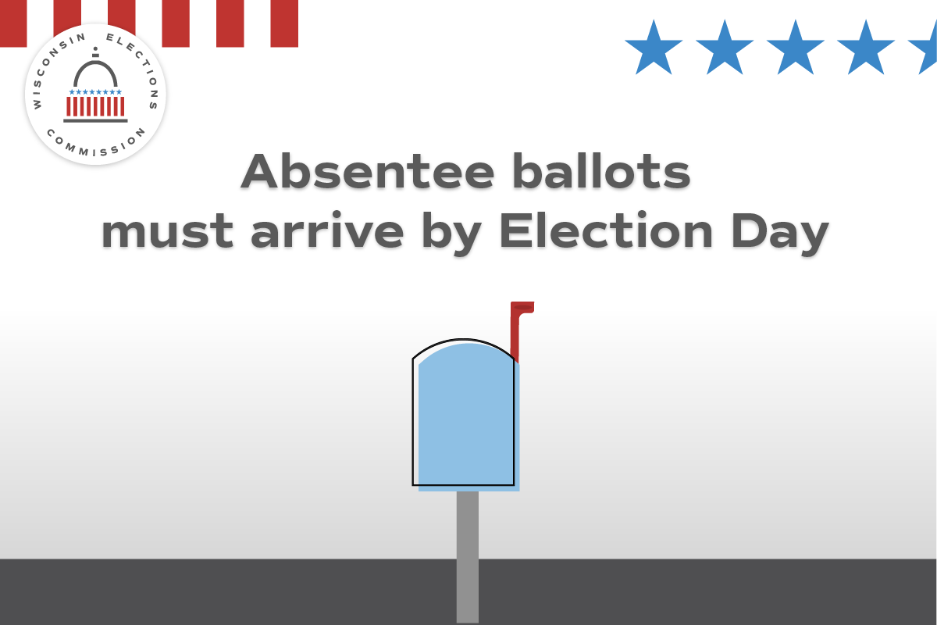
Absentee | Use on or after March 14 | 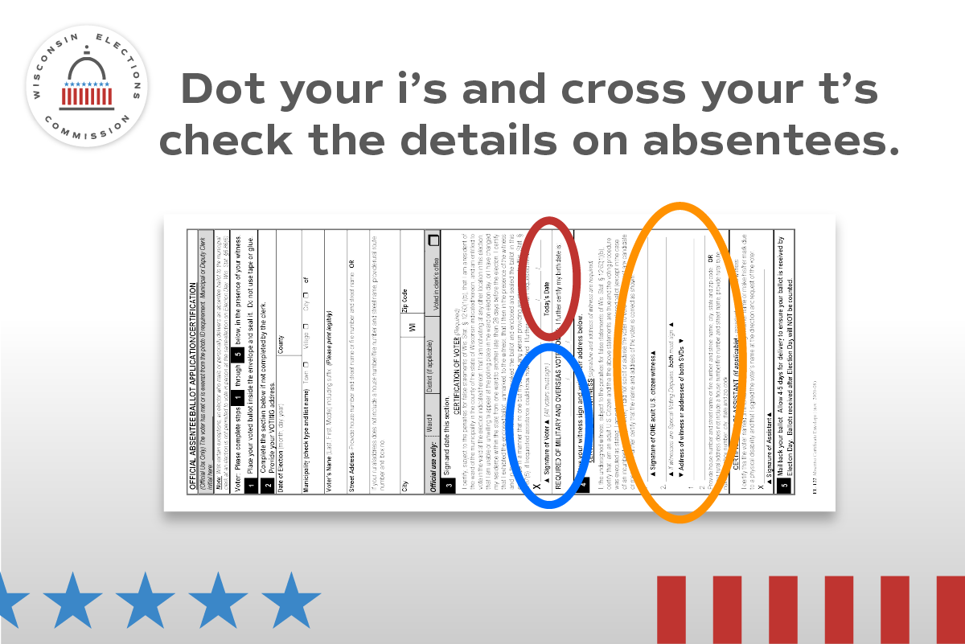  When voting absentee, pay close attention to the included instructions. Make sure your voter information is correct, that you've signed, and that your witness has provided their name and full address clearly on the return certificate envelope.
Registration | Use on or before March 15  After March 15, alter the post to read, “Missed your chance to register to vote online or by mail? You can still register at your clerk’s office until March 31 or at your polling place on Election Day.” | March 15 is the last day to register online to vote in the Spring Election! Start or update your registration at MyVote.wi.gov. If you miss it, you can still register at your clerk’s office until March 31 or at your polling place on Election Day.

Topic | Timing |  |  | Suggested copy and image
Witness | Use between March 14-23. |  |  | Line up a witness before you vote absentee by mail. You’ll need their signature and full address. Learn more at MyVote.wi.gov/en-us/VoteAbsentee.  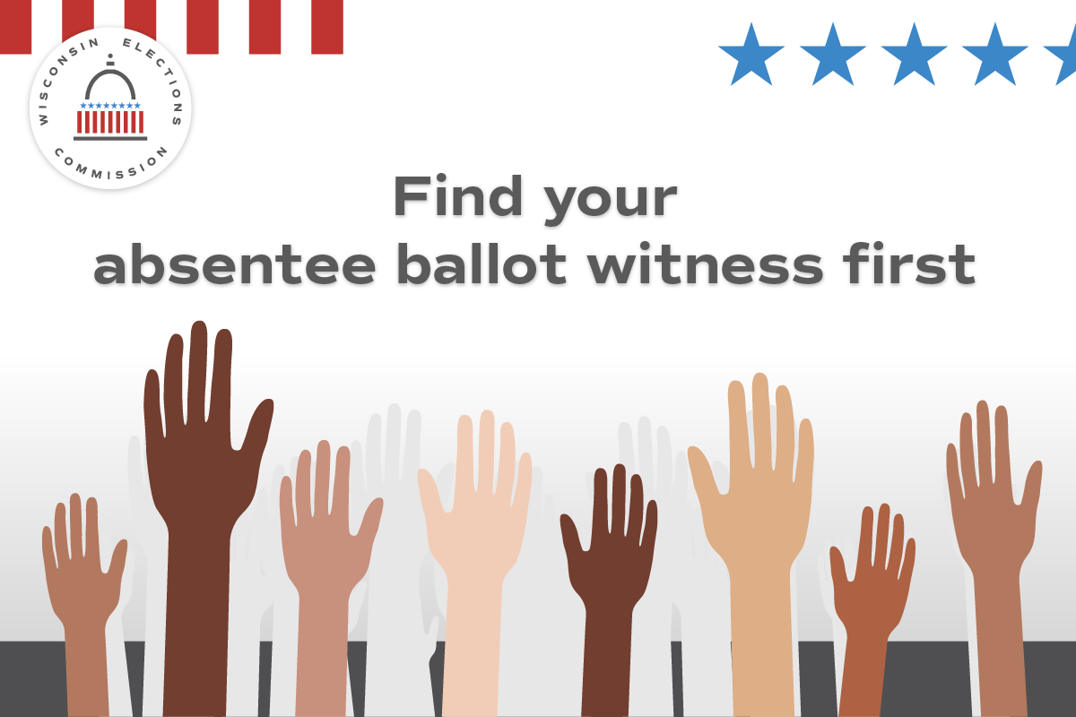
Absentee | Use any time on or after March 14 |  |  | Mailing in your absentee ballot is easy. Just remember to do it early! Your ballot must arrive by 8 p.m. on Election Day – April 4 – to be counted.
Poll Worker Recruitment | Use and promote as needed |  |  | Want to help your community and get paid? Serve as a poll worker! Visit https://myvote.wi.gov/en-us/Become-Pollworker to learn more.
Photo ID | Use any time before March 23. Modify after March 23 by deleting reference to absentee ballot request. |  |  | Your photo ID doesn’t need your current address. What ID will you use for your absentee ballot request or to vote at the polls on April 4? To learn more, visit https://bit.ly/3Dj48EQ  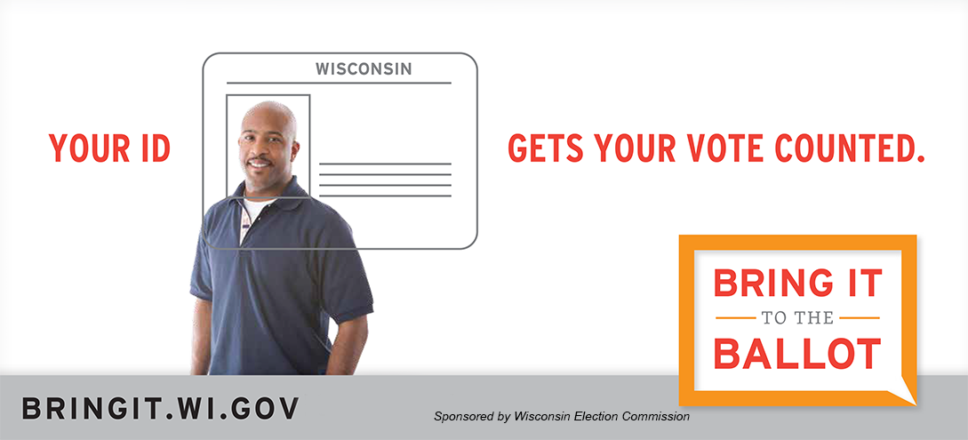
Security | Use any time |  |  | 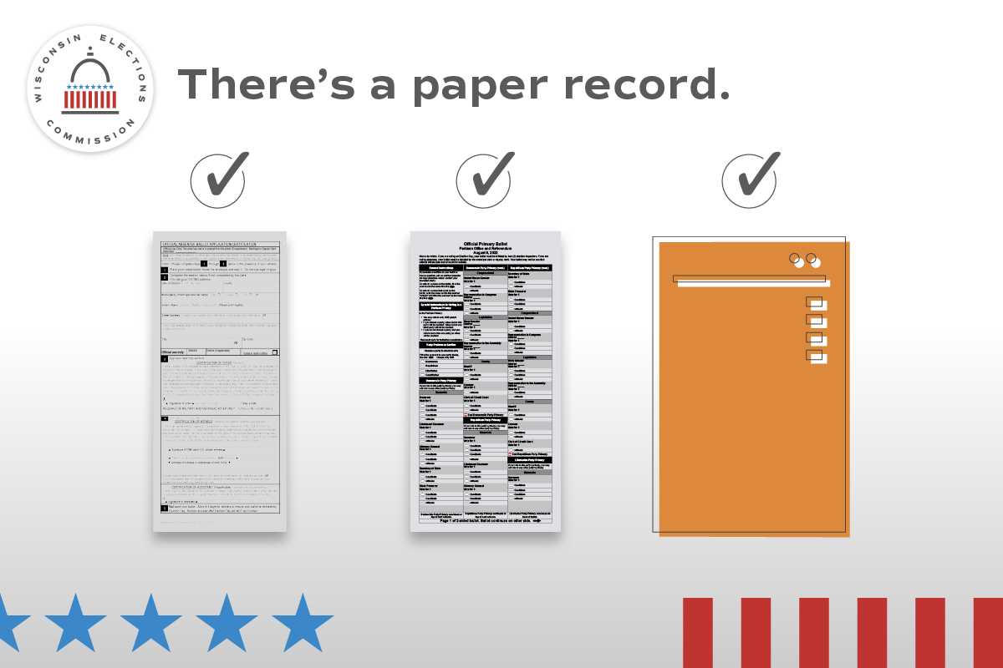  Every vote has a paper trail. Wisconsin requires a paper record of every vote that’s cast, no matter what kind of ballot or voting equipment used.
Registration | Use any time |  |  | The Spring Election is April 4! Are you registered to vote? Visit MyVote.wi.gov today to confirm in minutes.
Absentee | Use on or before March 23 |  |  | Voting in the April 4 Spring Election? Choose the option that’s right for you: at the polls, by in-person absentee ballot, or by mail absentee ballot.  MyVote.wi.gov  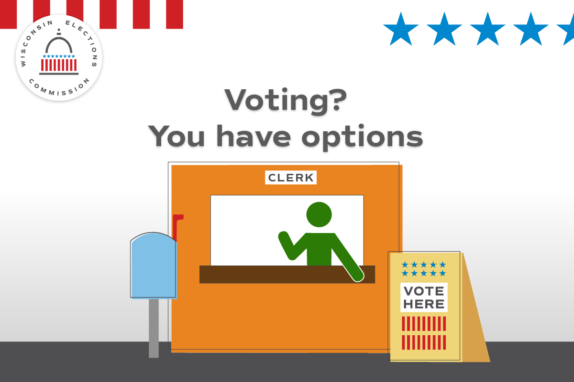
Registration |  | Use any time | The Spring Election is April 4! Are you registered to vote? Visit https://myvote.wi.gov
Security |  | Use any time, as frequently as you wish until and after Election Day. | There are multiple checks on Wisconsin elections to keep them secure and accurate.  Learn more at https://elections.wi.gov/101  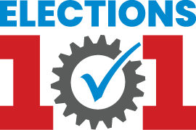
Photo ID |  | Use any time | Don’t forget to bring your photo ID to the polls on April 4! Visit https://elections.wi.gov/photoid for more info about all the forms of ID accepted for voting, including how to get a free ID!  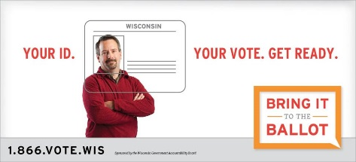

Topic |  | Timing | Suggested copy and image
Absentee |  | Use on or before March 28 | Finished filling out your absentee ballot? Don’t wait to mail it back or deliver it in person.  Remember, voters who require assistance due to a disability can select someone to return their ballot.
General Info |  | Use any time | Do you know where your polling place will be for the April 4 Spring Election? Confirm your polling place location at https://MyVote.wi.gov/en-us/find-my-polling-place
Absentee | Use on or before March 28 |  | Finished filling out your absentee ballot? Don’t wait to mail it back! All absentee ballots must arrive by 8 p.m. on April 4.  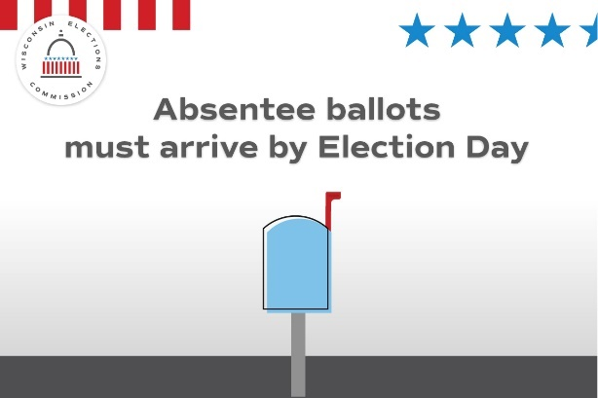
IPAV | Use by April 2 or last day of in-person absentee voting offered in your community. |  | Cast your ballot before Election Day by voting an in-person absentee ballot at our office! Our hours are (INSERT HOURS OR BY APPOINTMENT INFO HERE).  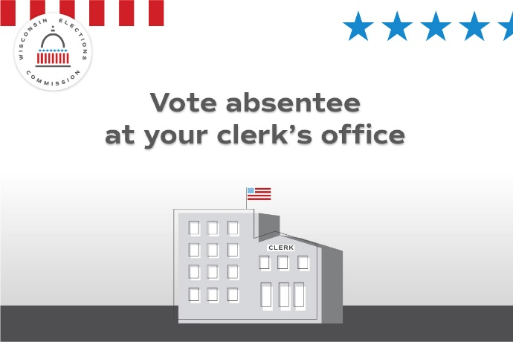

General info | Use any time | Did you know? Wisconsin’s elections are run by local clerks in each of the state’s approximately 1,850 cities, villages and towns.  Local election officials are your neighbors, friends, and relatives.
Security | Use any time | Want to know more about how Wisconsin runs elections? Visit https://elections.wi.gov/faq.  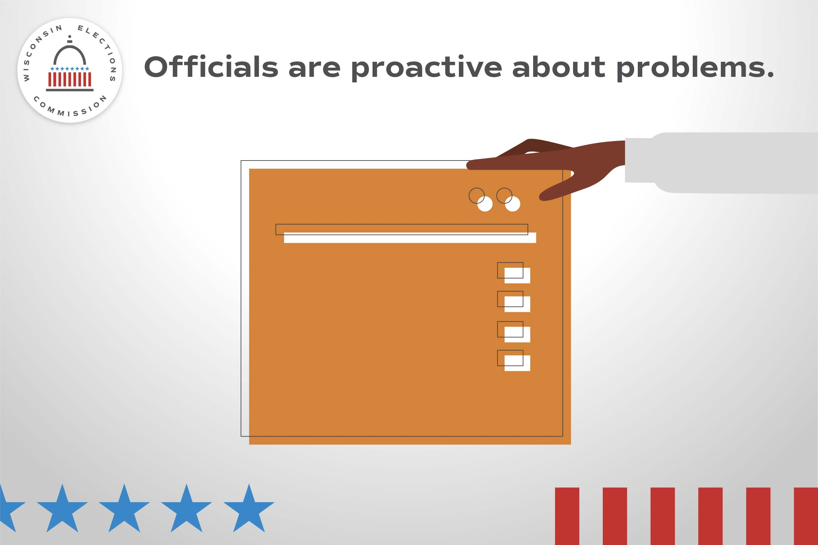

Absentee | Use any time | Haven’t returned your absentee ballot? You can still drop it off before 8 p.m. on Election Day, April 4. [Clerk insert proper drop off locations]
General Info | Use any time | Get ready to vote on April 4 by seeing what’s on your ballot. Visit MyVote.wi.gov for more information.
Results reminder | Use any time | It may take a while for local clerks to report unofficial results on Election Night, even as late as the next morning.  Remember, ALL Election Night results are unofficial.  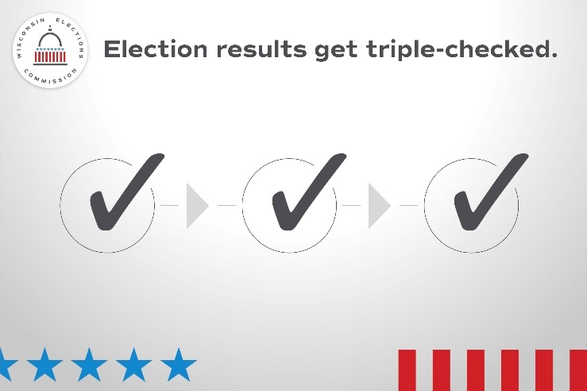

Social Media posts for use April 4, Election Day
Focus of the day -- General election info.
Topic | Timing | Suggested copy and image
Election Day | Use only on April 4 | It’s Election Day! All polling places will be open from 7 a.m. to 8 p.m. Find your polling place at MyVote.wi.gov  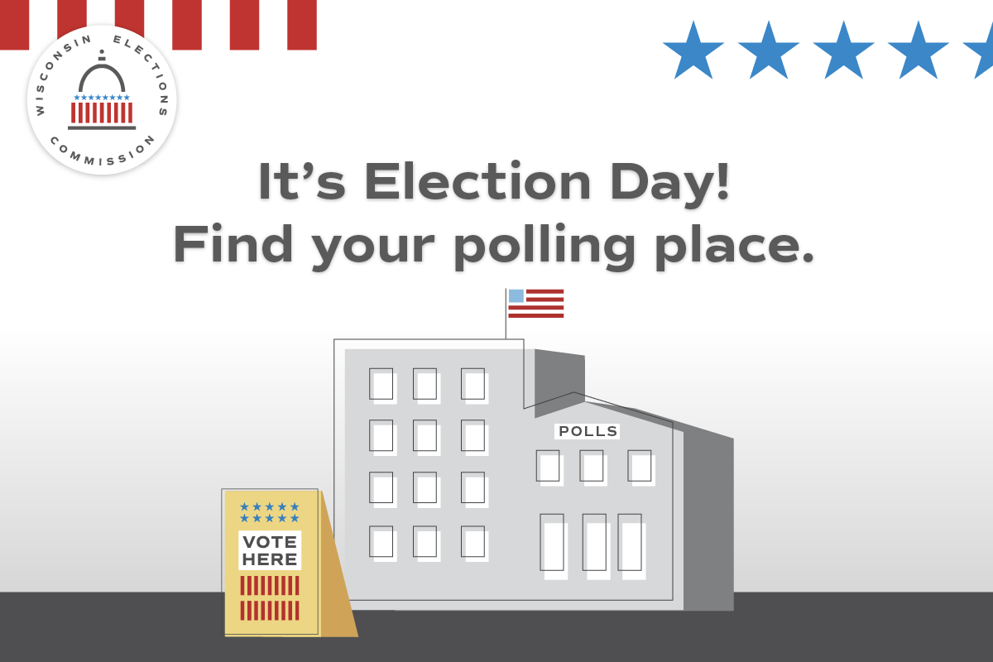
Election Day | Use only on April 4 | Still have your absentee ballot? Drop it off now! You can take it to [clerk: insert proper drop off options]  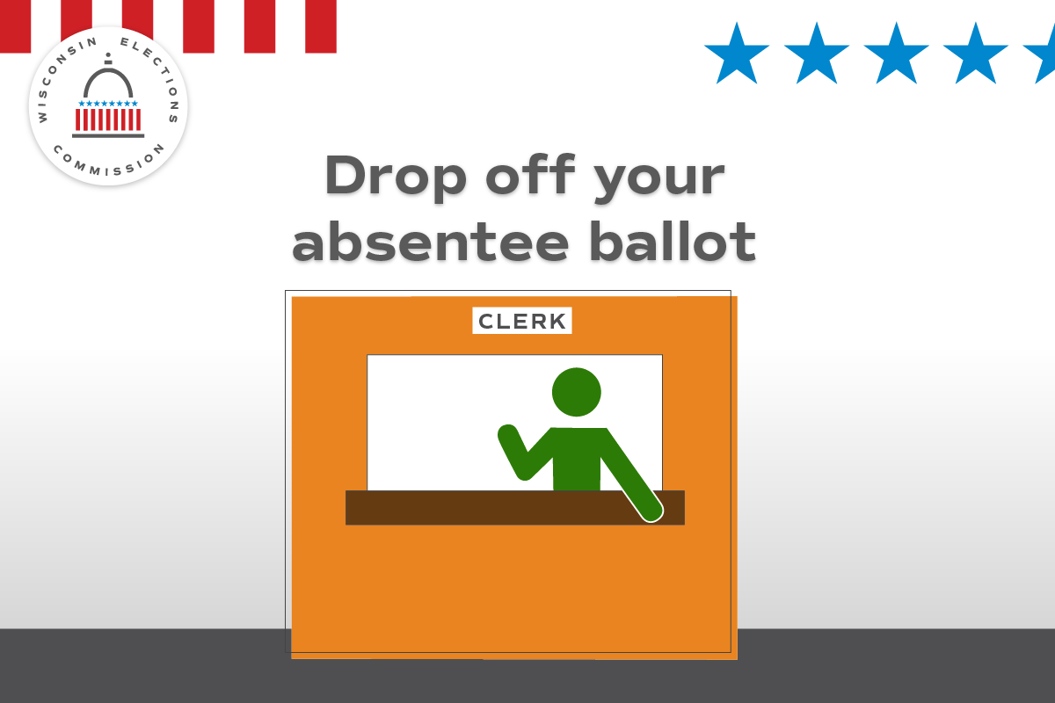
Security | Use only on April 4 | In Wisconsin, state-level election results aren’t official until they’ve been reviewed at the local level, double-checked by county officials, and certified by the state. Find out how Wisconsin delivers election results you can count on at https://elections.wi.gov/elections/election-security-integrity

