Spring Primary 2025 Suggested Social Media Posts
Topic | Timing | Suggested copy and image
Photo ID | Use any time | Interested in getting a free ID for voting purposes? Visit https://elections.wi.gov/photoid for more information and to get ready for the Feb. 18 Spring Primary!  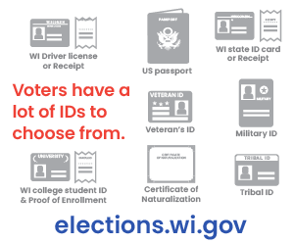
IPAV | Use on Feb. 4 and until Feb. 16, or the last day your community offers IPAV options. | Starting Feb. 4 voters can request an absentee ballot in person at the clerk’s office or at another designed location for the Spring Primary. The deadline for in-person voting is Feb. 16, but not all municipalities offer it until then. Check with your local clerk’s office for your in-person voting options.  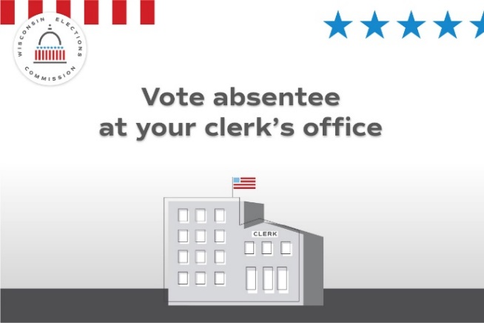
Absentee ballots | Use any time, preferably multiple times ahead of Election Day. | An absentee ballot must be placed in the mail by the voter, or the voter must personally deliver it to the municipal clerk at the clerk's office, alternate site, polling place, or central count location. Ballots must be returned by 8 p.m. on Spring Primary Election Day, Feb. 18.  Voters who need assistance due to disability can select someone to return the ballot.  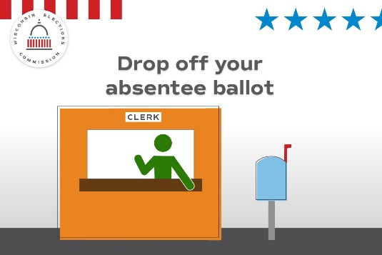
Public testing of election equipment | Use on or before Feb. 8 and the days following, depending when your public tests will occur. | Want to watch a public test of voting equipment for the Spring Primary? That testing can start on Feb. 8. Info for your community’s public test is available here: (Insert link to local testing notice)  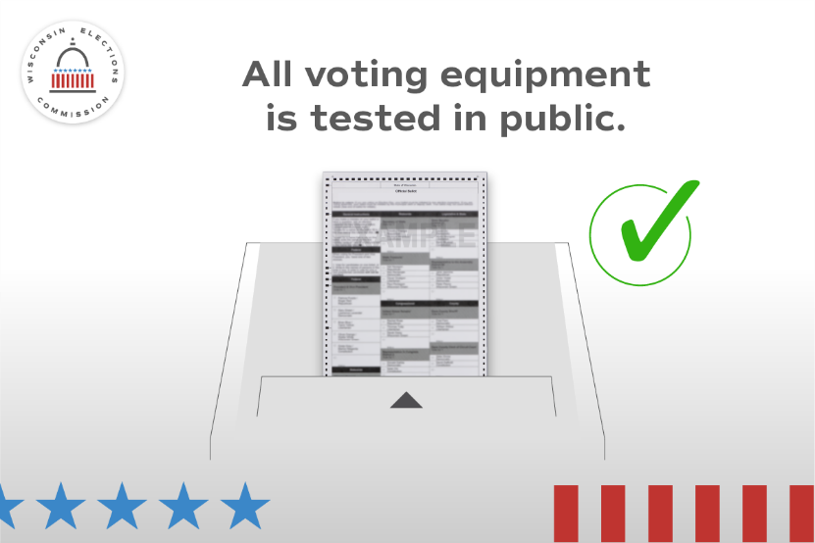
Absentee ballot requests | Use on or before Feb. 13, the last day to request ballots by mail, online, email or fax. | Looking to vote absentee in the Spring Primary? Take action now, because Feb. 13 is the last day to request an absentee ballot by mail, online, email, or fax. Ballots must be returned by 8 p.m. on Election Day, Feb. 18, in order to be counted.  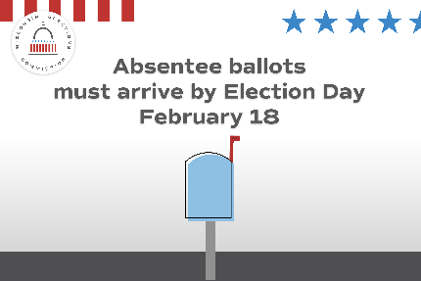
Disability rights | Use any time, preferably multiple times ahead of Election Day. | 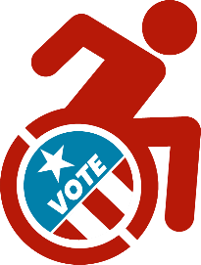  Voters with disabilities have options: If you need help returning an absentee ballot, the law guarantees your right to select a person (except an employer or union rep.) to mail or deliver it to the clerk’s office, alternate site, polling place, or central count location.

Photo ID | Use any time | Don’t have an ID for voting or a document like a birth certificate? Get a free ID using the DMV’s ID Petition Process https://elections.wi.gov/photoid  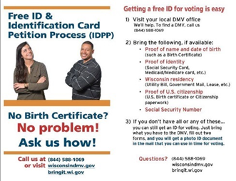
Registration | Use anytime, before and on Feb. 14, the last day to register in person | Are you registered for the Spring Primary? If not, act soon! Feb. 14 is the last day to register in your clerk’s office or another designed site.  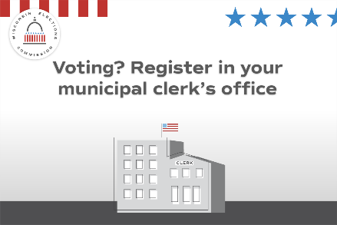
Absentee | Use any time before Election Day | Finished filling out your absentee ballot? It may be too late to mail it back. Instead, consider dropping it off at (INSERT DROP OFF OPTIONS BEFORE AND ON ELECTION DAY)

Poll Worker Recruitment | Use asap and promote as needed |  |  | Want to help your community and get paid? Serve as a poll worker! Visit https://myvote.wi.gov/en-us/Become-PollWorker  
Photo ID | Use any time |  |  | Your photo ID doesn’t need your current address. What ID will you use to vote in the Spring Primary on Feb. 18? https://elections.wi.gov/photoid  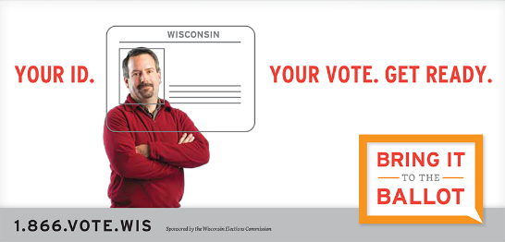
Security | Use any time |  |  | 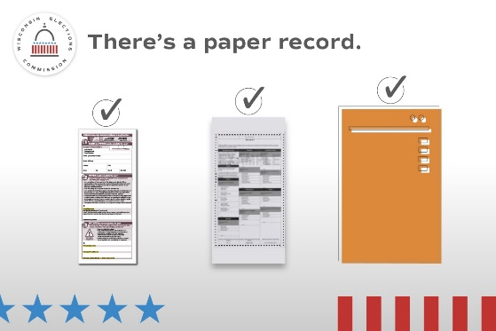  Every vote has a paper trail. Wisconsin requires a paper record of every vote that’s cast, no matter what kind of ballot or voting equipment used.
Security |  | Use any time, as frequently as you wish until and after Election Day. | There are multiple checks on Wisconsin elections to keep them secure and accurate.  Learn more at elections.wi.gov/101  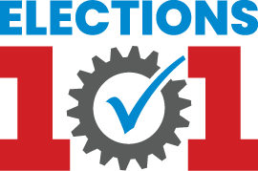
Photo ID |  | Use any time | Don’t forget to bring your photo ID to the polls on Feb. 18 for the Spring Primary! Visit https://elections.wi.gov/photoid for more info about all the forms of ID accepted for voting, including how to get a free ID!  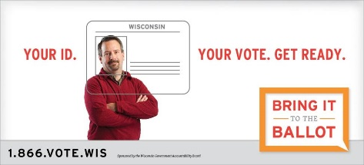

Absentee |  | Use before Election Day | Finished filling out your absentee ballot? It may be too late to mail it back. Instead, consider dropping it off before Election Day at (INSERT DROP OFF OPTIONS BEFORE ELECTION DAY) or on Election Day before polls close at (INSERT OPTIONS).  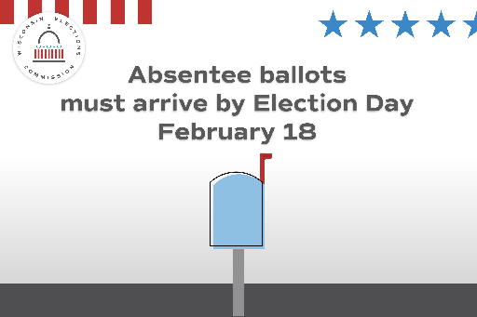
General Info |  | Use any time | Do you know where your polling place is for the Feb. 18 Spring Primary? Confirm your polling place location at https://myvote.wi.gov/en-us/Find-My-Polling-Place  
IPAV | Use by Feb. 16 or last day of in-person absentee voting offered in your community. |  | Cast your ballot before Election Day by voting an in-person absentee ballot at our office! Our hours are (INSERT HOURS OR BY APPOINTMENT INFO HERE).  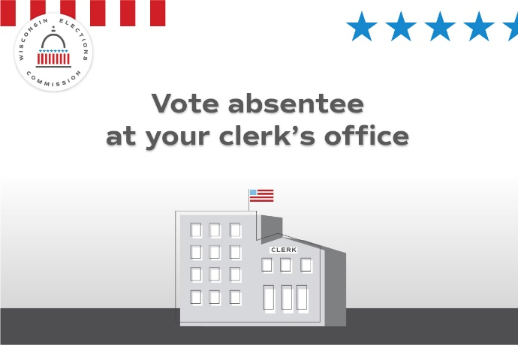

Absentee | Use any time | Haven’t returned your absentee ballot yet? You can still drop it off before Election Day at (INSERT DROP OFF LOCATIONS) or on Election Day at (INSERT DROP OFF LOCATIONS). All absentee ballots must arrive before polls close on Feb. 18.  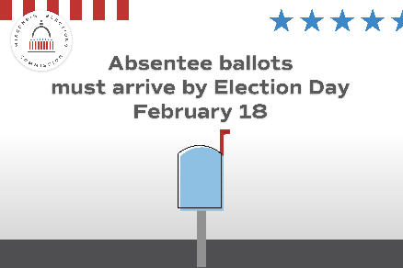
General Info | Use any time | Get ready to vote on Feb. 18 by seeing what’s on your ballot. Visit MyVote.wi.gov for more information.

Social Media posts for use Feb. 18, Election Day
Focus of the day -- General election info.
Topic | Timing | Suggested copy and image
Election Day | Use only on Feb. 18 | It’s Election Day! All polling places will be open from 7a.m, to 8 p.m. Find your polling place at MyVote.wi.gov  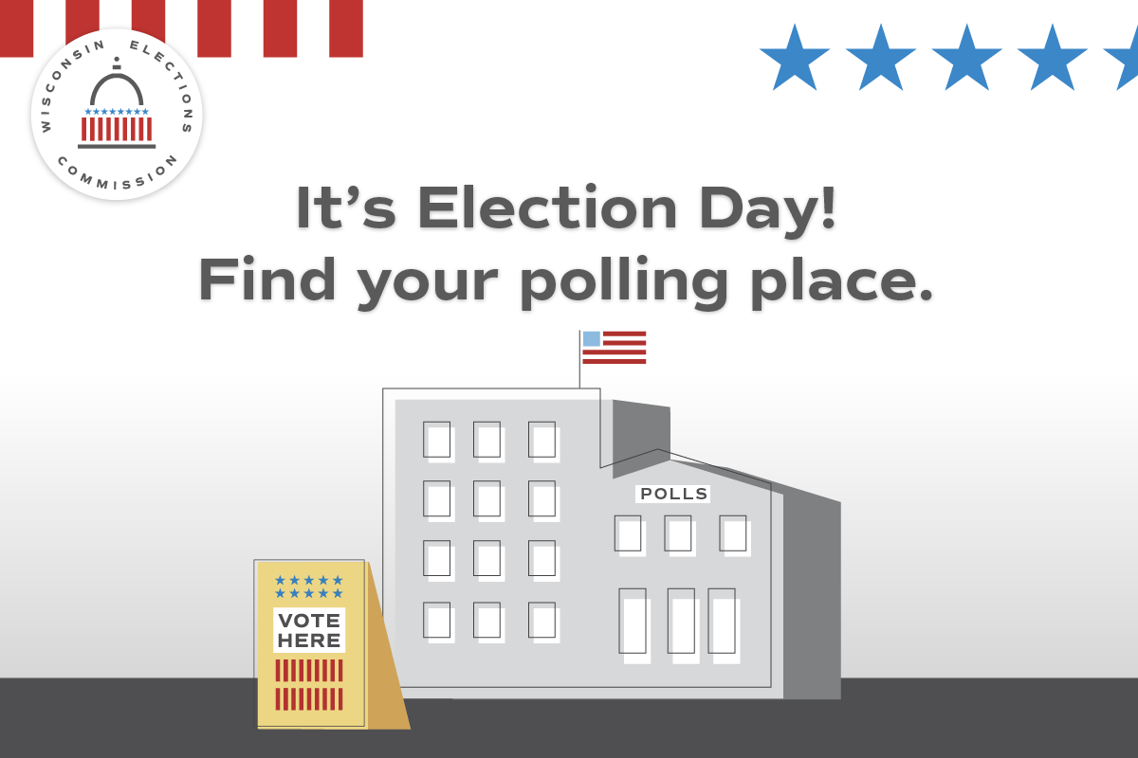
Election Day | Use only on Feb. 18 | Still have your absentee ballot? Drop it off TODAY before polls close at (INSERT DROP OFF LOCATIONS)!  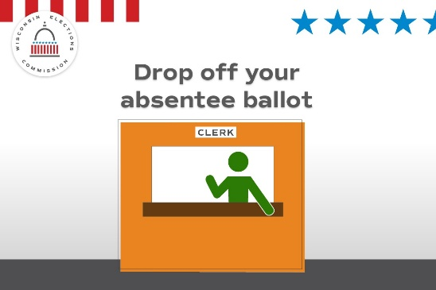
Security | Use only on Feb. 18 | In Wisconsin, election results aren’t official until they’ve been reviewed at the local level, double-checked by county officials, and certified by the state. Find out how Wisconsin delivers election results you can count on at https://elections.wi.gov/elections/election-security-integrity  