Spring Election 2024 Suggested Social Media Posts
Topic | Timing | Suggested copy and image
Photo ID | Use any time | Interested in getting a free ID for voting purposes? Visit https://elections.wi.gov/photoid for more information and to get ready for April 2!  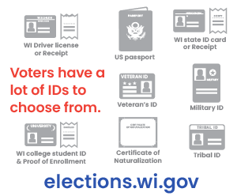
Absentee ballots | Use any time, preferably multiple times ahead of Election Day. | An absentee ballot must be placed in the mail, or the voter must personally deliver it to the municipal clerk at the clerk's office, alt. site, polling place, or central count location.  Voters who need assistance due to disability can select someone to return the ballot.  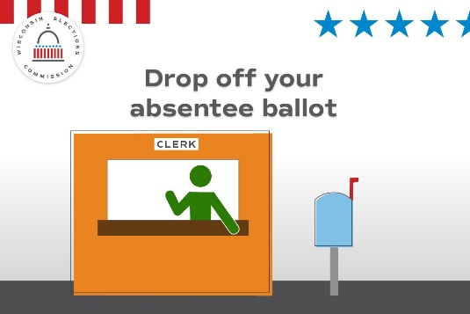
Disability rights | Use any time, preferably multiple times ahead of Election Day. | 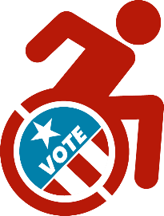  Voters with disabilities have options: If you need help returning an absentee ballot, the law guarantees your right to select a person (except an employer or union rep) to mail or deliver it to the clerk’s office, alt. site, polling place, or central count location.
Registration | Use on or before March 28 | Are you prepared for the April 2 Spring Election?  Register early if you can, either at your local clerk’s office by March 29 or at the polls on Election Day. Confirm your registration at MyVote.wi.gov.  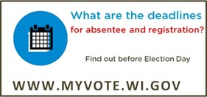
Registration | Use any time | The Spring Election is April 2! Are you registered to vote? Visit MyVote.wi.gov today to confirm in minutes.
IPAV | Use by March 31 or last day of in-person absentee voting offered in your community | Cast your ballot before Election Day by voting an in-person absentee ballot at our office! Our hours are (INSERT HOURS OR BY APPOINTMENT INFO HERE)  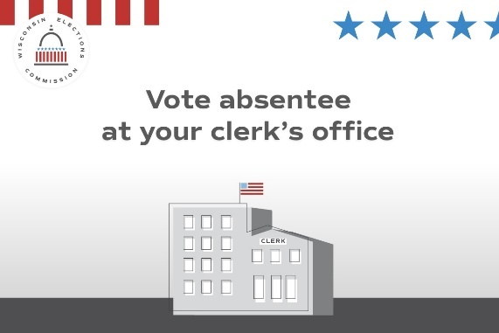
General info | Use any time | Wisconsin’s elections are run by local clerks in each of the state’s approximately 1,850 cities, villages, and towns.  Local election officials are your neighbors, friends, and relatives.
Security | Use any time | Want to know more about how Wisconsin runs elections? Visit https://elections.wi.gov/faq

Photo ID | Use any time | Don’t have an ID for voting or a document like a birth certificate? Get a free ID using the DMV’s ID Petition Process https://elections.wi.gov/photoid  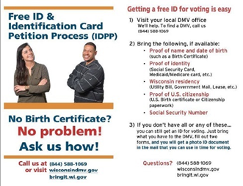

Poll Worker Recruitment | Use and promote as needed |  | Want to help your community and get paid? Serve as a poll worker! Visit https://myvote.wi.gov/en-us/Become-PollWorker
Photo ID | Use any time |  | Your photo ID doesn’t need your current address. What ID will you use to vote at the polls on April 2? https://elections.wi.gov/photoid  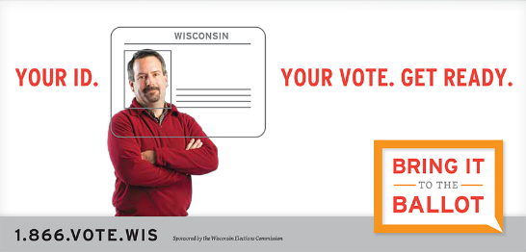
Security | Use any time |  | 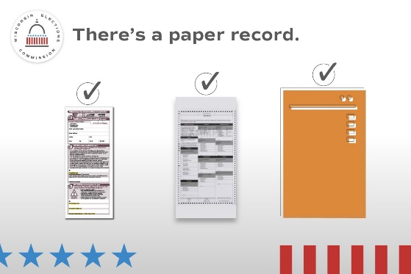  Every vote has a paper trail. Wisconsin requires a paper record of every vote that’s cast, no matter what kind of ballot or voting equipment used.
Security |  | Use any time, as frequently as you wish until and after Election Day. | There are multiple checks on Wisconsin elections to keep them secure and accurate.  Learn more at elections.wi.gov/101  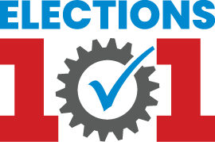
Photo ID |  | Use any time | Don’t forget to bring your photo ID to the polls on April 2! Visit https://elections.wi.gov/photoid for more info about all the forms of ID accepted for voting, including how to get a free ID!  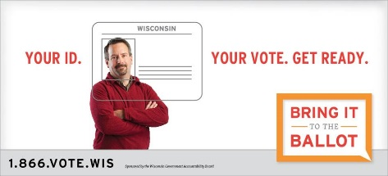

Absentee |  | Start using March 27 | Finished filling out your absentee ballot? It may be too late to mail it back. Instead, consider dropping it off before Election Day at (INSERT DROP OFF OPTIONS BEFORE ELECTION DAY) or on Election Day before polls close at (INSERT OPTIONS).  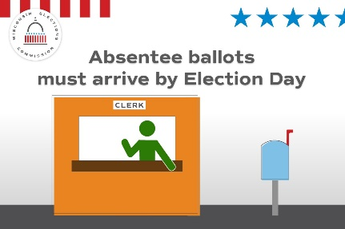
General Info |  | Use any time | Do you know where your polling place is for the April 2 Spring Election? Confirm your polling place location at https://myvote.wi.gov/en-us/Find-My-Polling-Place  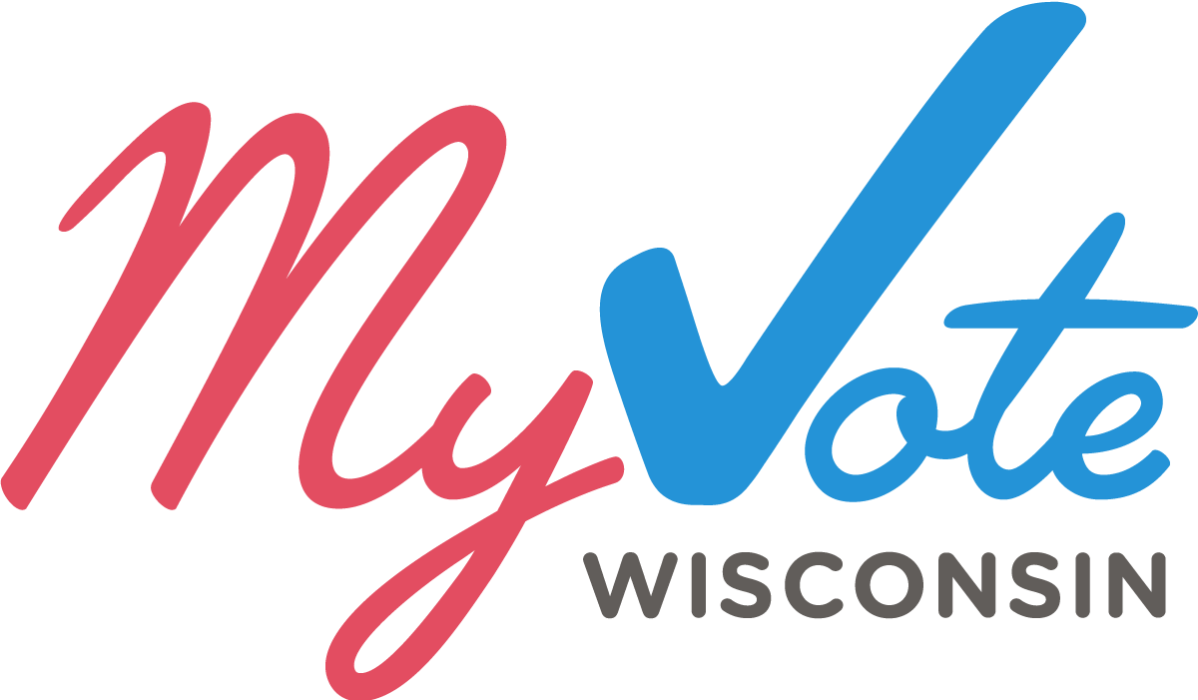
IPAV | Use by March 31 or last day of in-person absentee voting offered in your community. |  | Cast your ballot before Election Day by voting an in-person absentee ballot at our office! Our hours are (INSERT HOURS OR BY APPOINTMENT INFO HERE).  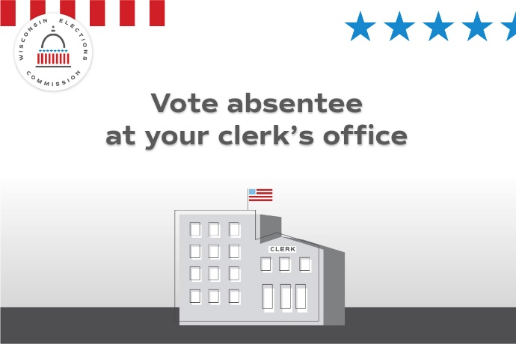

Absentee | Use any time | Haven’t returned your absentee ballot yet? You can still drop it off before Election Day at (INSERT DROP OFF LOCATIONS) or on Election Day at (INSERT DROP OFF LOCATIONS). All absentee ballots must arrive before polls close on April 2.  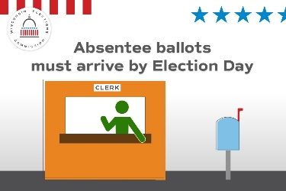
General Info | Use any time | Get ready to vote on April 2 by seeing what’s on your ballot. Visit MyVote.wi.gov for more information.
Social Media posts for use April 2, Election Day
Focus of the day -- General election info.
Topic | Timing | Suggested copy and image
Election Day | Use only on April 2 | It’s Election Day! All polling places will be open from 7am to 8pm. Find your polling place at MyVote.wi.gov  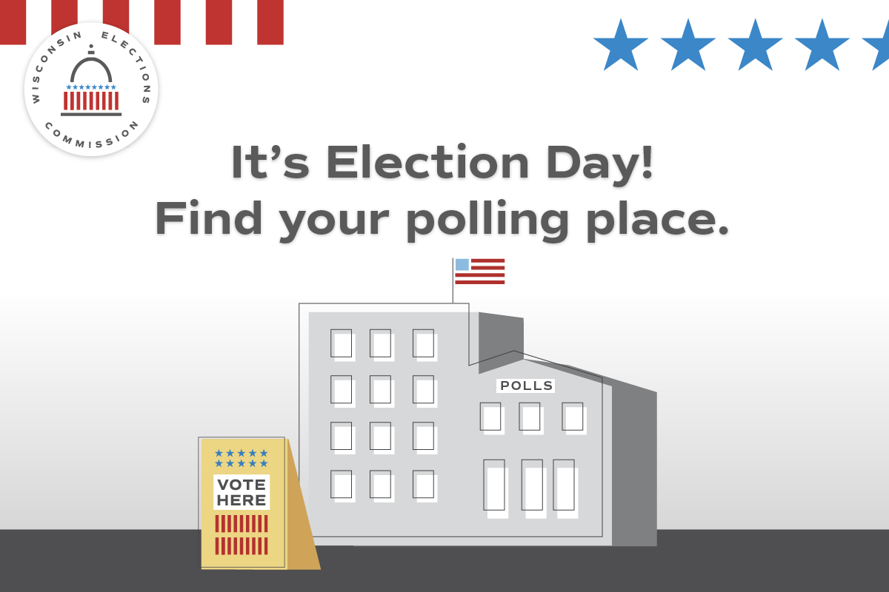
Election Day | Use only on April 2 | Still have your absentee ballot? Drop it off TODAY before polls close at (INSERT DROP OFF LOCATIONS)!  