Social Media Calendar for Partisan Primary on Aug. 13
Posts for Week of July 7-12
Focus of the week – Q&A about voting absentee, registration, general election info, what to do with absentees.
Topic | Timing? | Suggested copy and image
Registration | Use by July 24 | Before you can vote in the August Partisan Primary, you must be registered to vote. If you have an up-to-date WI driver license or ID you can register online at https://myvote.wi.gov/en-us/ by July 24.  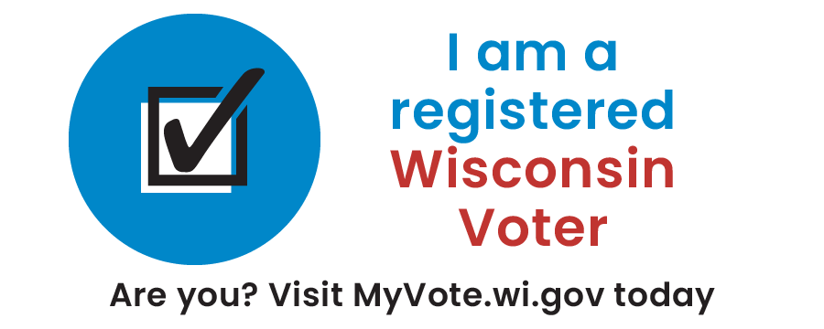
Absentee/MyVote | Use by July 30 | Registered, eligible WI voters can use https://myvote.wi.gov/en-us/ to request an absentee ballot and submit a copy of their acceptable photo ID.  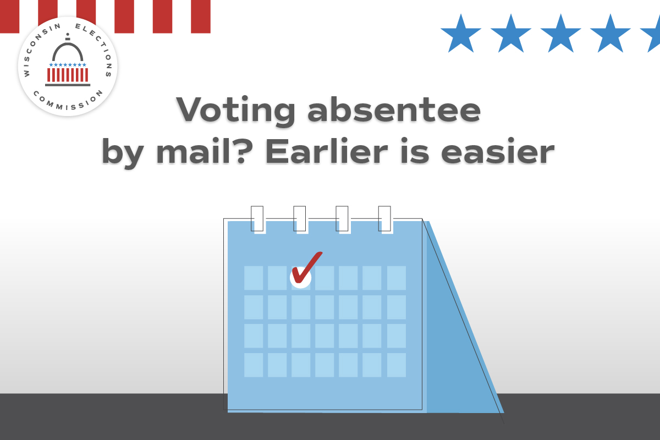

Absentee/MyVote | Use by July 30 | Registered, eligible WI voters can request an absentee ballot by mail at https://myvote.wi.gov/en-us/. Act now to vote by mail for the August election.  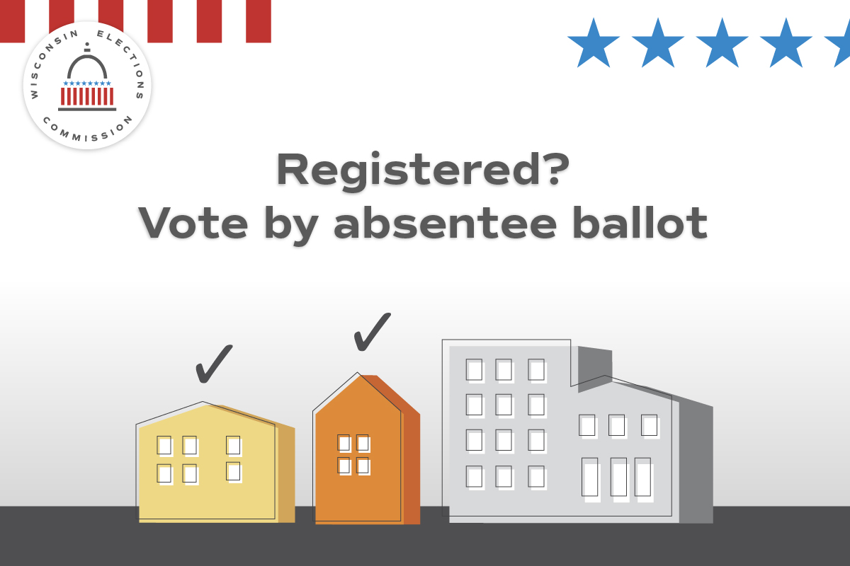
Voting Options | Use by July 30 | Voting in the August Partisan Primary? Choose the option that’s right for you: at the polls; absentee by mail; or absentee in person. Visit https://myvote.wi.gov/en-us/ to learn more.  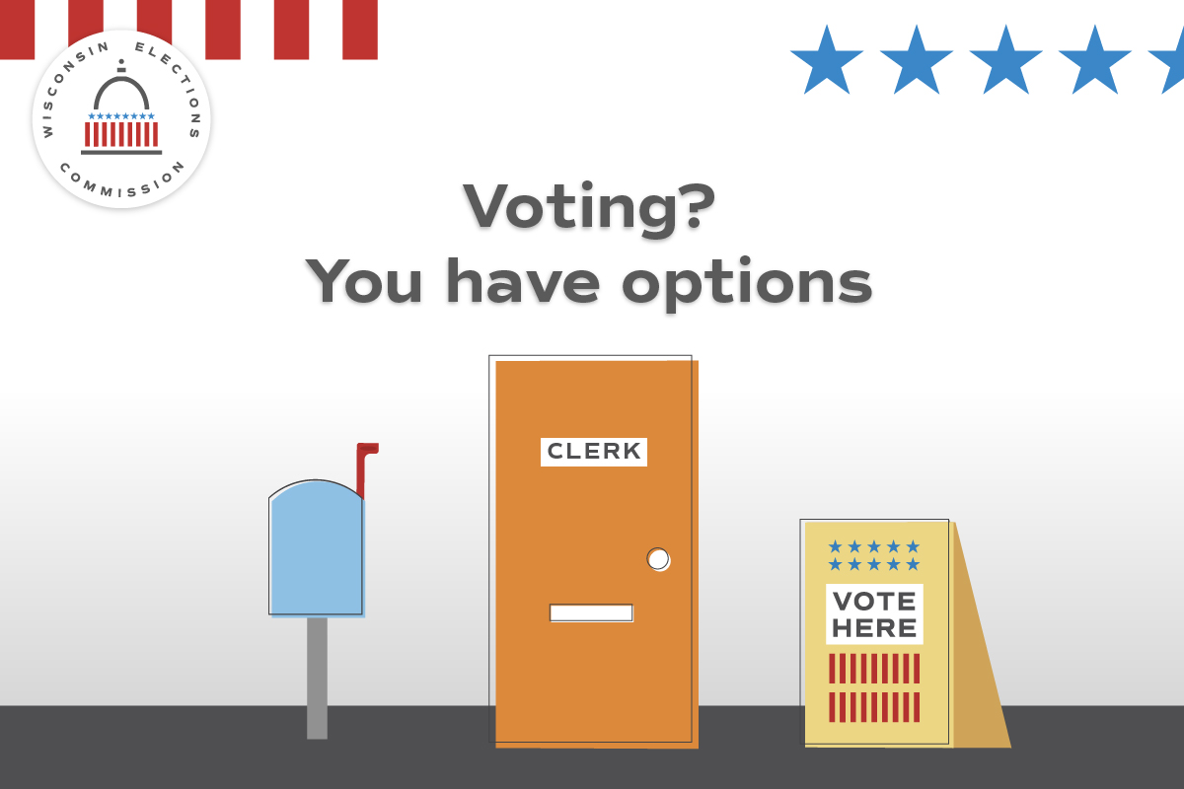

Topic | Timing? | Suggested copy and image
Absentee/MyVote | Use by July 30 | Registered, eligible WI voters can request an absentee ballot for the Aug. 13 Primary Election at https://myvote.wi.gov/en-us/!
Absentee/MyVote | Use anytime | Already made your absentee ballot request for the Aug. 13 Partisan Primary? Track the status of your ballot at https://myvote.wi.gov/en-us/.
Registration/MyVote | Use anytime | The Partisan Primary is August 13! Are you registered to vote? Visit https://myvote.wi.gov/en-us/ and confirm your registration is up-to-date today.  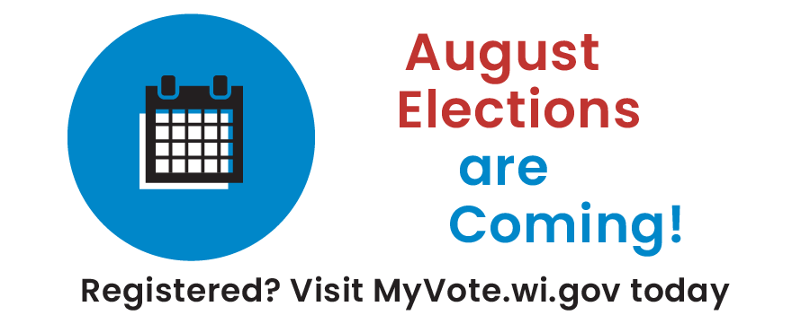
Photo ID | Use by July 30 | Whether you vote at the polls or by absentee, you’ll need to provide an acceptable photo ID. Visit https://elections.wi.gov/photoid for more info about all the forms of ID accepted for voting, including how to get a free ID for voting!  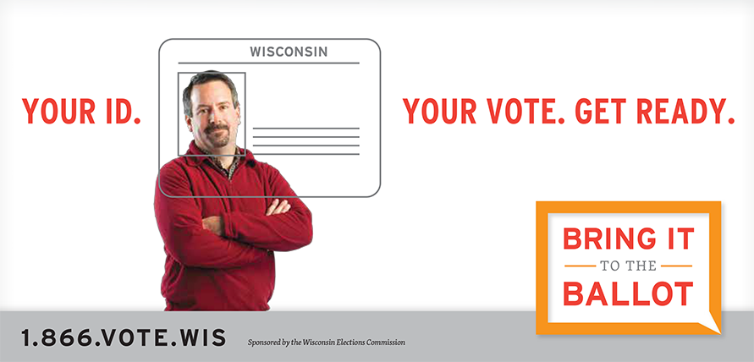

Witness | Use by Aug. 6 | If you’re voting absentee by mail for the August Primary, remember you’ll need a witness. Your witness can be your spouse, neighbor, or even your friend! Learn more at https://myvote.wi.gov/en-us/Vote-Absentee-By-Mail!  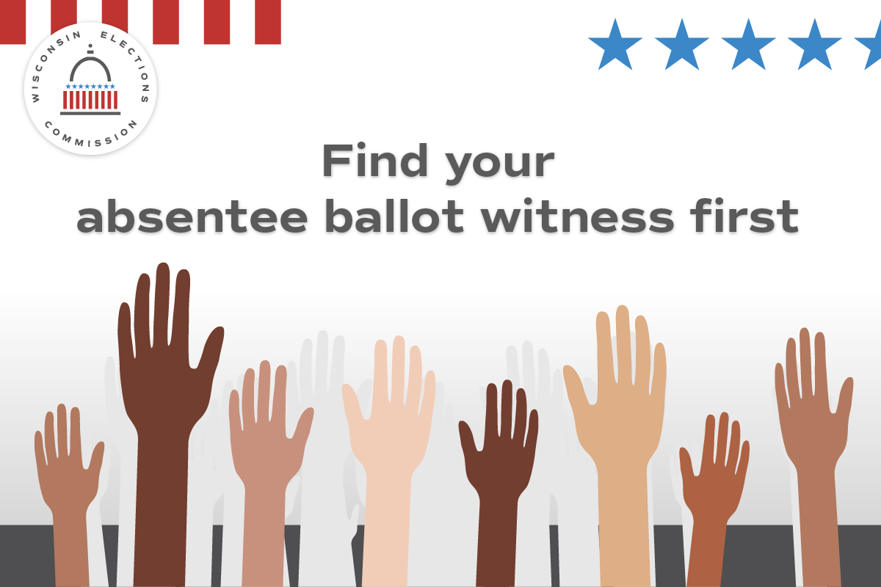

Registration | Use by July 24 | If you’ve moved or changed your name, you must re-register to vote. If you have an up-to-date WI driver license or ID you can register at https://myvote.wi.gov/en-us/.  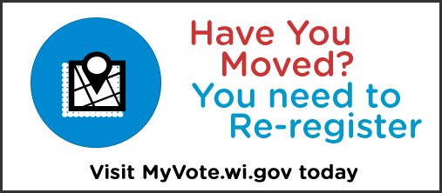
Registration | Use until July 24 | Voting in the Aug. 13 Partisan Primary? Are you registered to vote and is your voter registration up-to-date? The last day to register online at https://myvote.wi.gov/en-us/ or by mail is July 24. You can also register at your clerk’s office or at your polling place on Election Day.  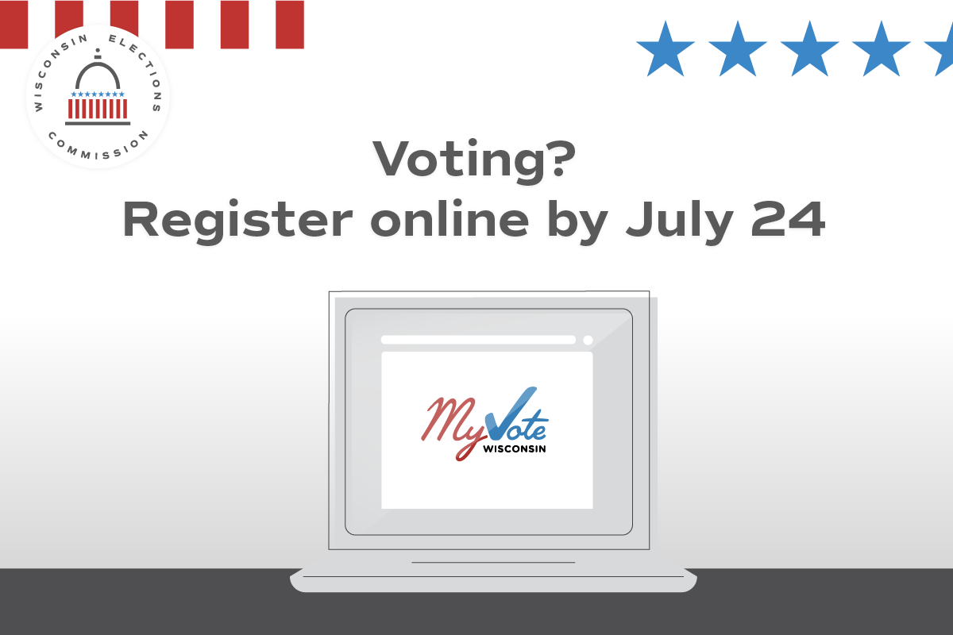
Absentee | Use before Aug. 6. | Finished filling out your absentee ballot? Mail it back at least one week before Election Day to ensure it arrives on time.  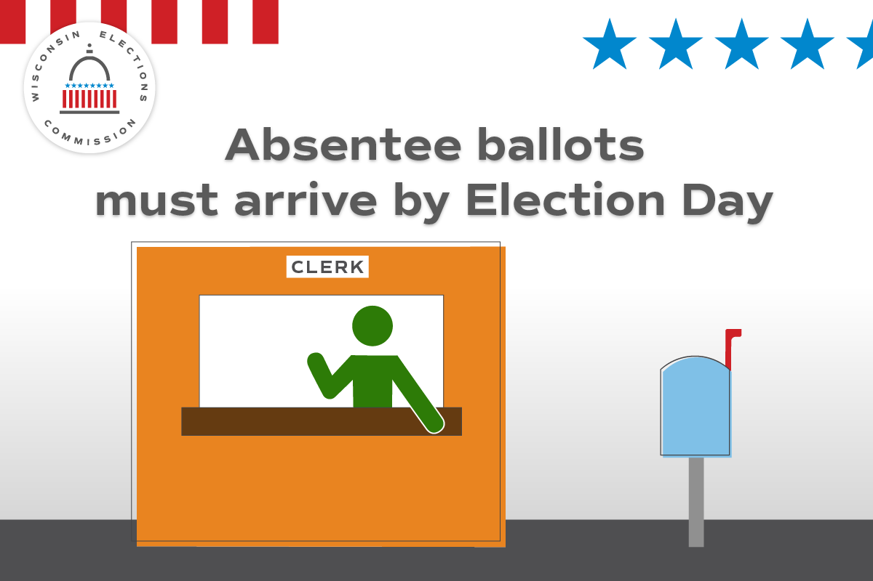

July 13-20
Focus of the week – General election info.
Topic | Timing? | Suggested copy and image
General info | Use ONLY on July 13 | Only one month until Election Day! Do you have a plan to vote? Confirm your registration, request your absentee ballot, or find your polling place all at https://myvote.wi.gov/en-us/!  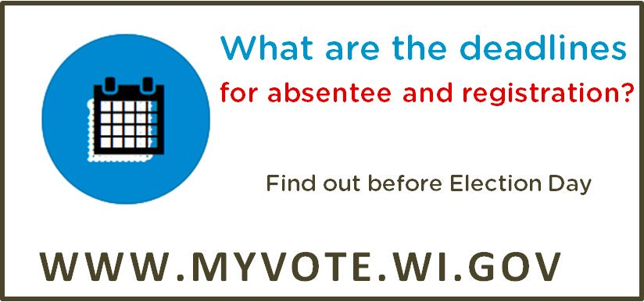
Registration | Use through July 24 | July 24 is the last day to register to vote online for the Aug. 13 Primary! Start or update your registration at https://myvote.wi.gov/en-us/. If you miss it, you can still register in your clerk’s office or at your polling place on Election Day.  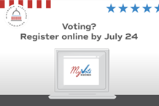
Witness | Use by Aug. 6 | If you’re voting absentee by mail, remember you’ll need a witness. This person could be your spouse, neighbor, friend, or any adult U.S. citizen. Learn more at https://myvote.wi.gov/en-us/Vote-Absentee-By-Mail.
Absentee | Use by July 30 | Want to vote absentee by mail? Don’t wait! Request your absentee ballot at https://myvote.wi.gov/en-us/!  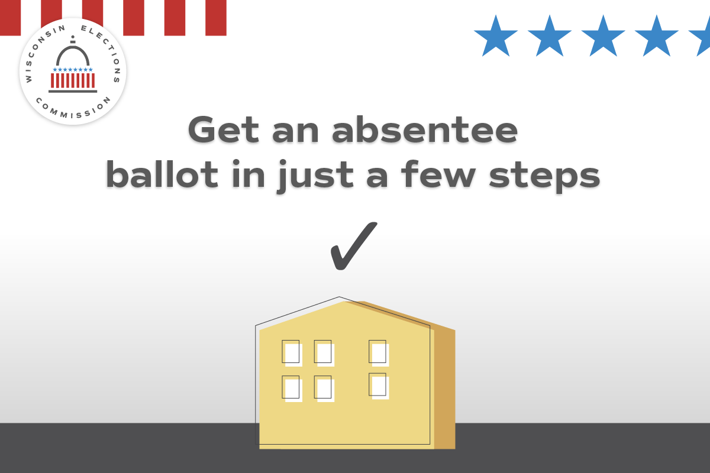
Absentee | Use anytime | Mailing in your absentee ballot is easy. Just remember to do it early! Your ballot must arrive by Election Day to be counted.
Absentee | Use by Aug. 6. | Finished filling out your absentee ballot? Mail it back at least a week before Election Day for it to arrive on time.
Poll Worker Recruitment | Promote as needed | Want to help your community and get paid? Serve as a poll worker! Contact our office at (LOCAL CONTACT INFO HERE) to learn more. You can also find your local clerk at https://myvote.wi.gov/en-us/.
Photo ID | Use by July 30 | Your photo ID for voting doesn’t need your current address. What ID will you use for your absentee ballot request or at the polls on August 13? https://bringit.wi.gov/
Photo ID | Use by Aug. 6. | Whether you’re voting at the polls or by absentee, you’ll need to provide an acceptable photo ID. Visit https://bringit.wi.gov/ for more info about all the forms of ID accepted for voting, including how to get a free ID!
General info | Use anytime. | Your polling place will be open on August 13 from 7 a.m. to 8 p.m. Confirm your polling place today at https://myvote.wi.gov/en-us/.  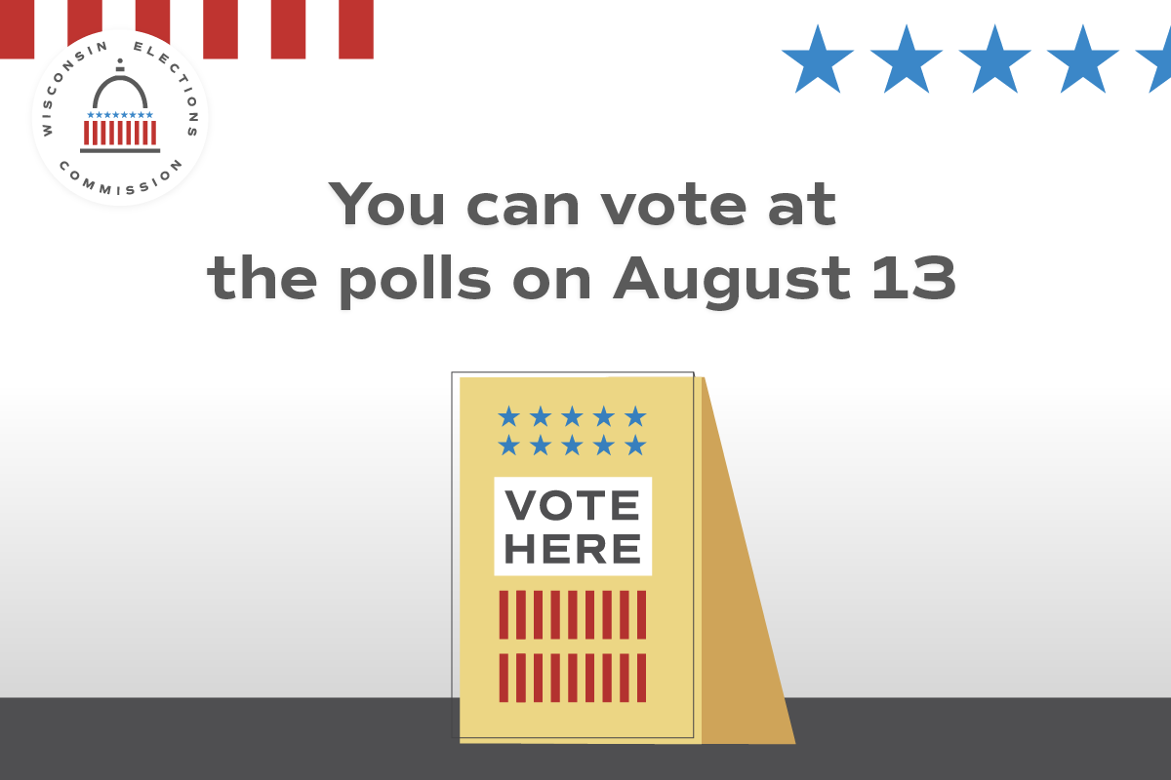
In person absentee | Use anytime on or before Aug. 11, the close of in-person absentee voting | Want to vote in the August election using an in-person absentee ballot? You can, starting on [INSERT DATE]. Learn more at https://myvote.wi.gov/en-us/Vote-Absentee-In-Person

July 21-27
Focus of the week – In person absentee voting reminders. Online registration deadline. General election info.
Topic | Timing? | Suggested copy and image
Registration | Use on July 24 | Today is the last day to register to vote online or by mail! Visit https://myvote.wi.gov/en-us/ for more info. You can still register at the polls on Election Day or at our office until [INSERT REGISTRATION DEADLINE FOR YOUR OFFICE]
Registration | Use July 25 to Aug. 8. | 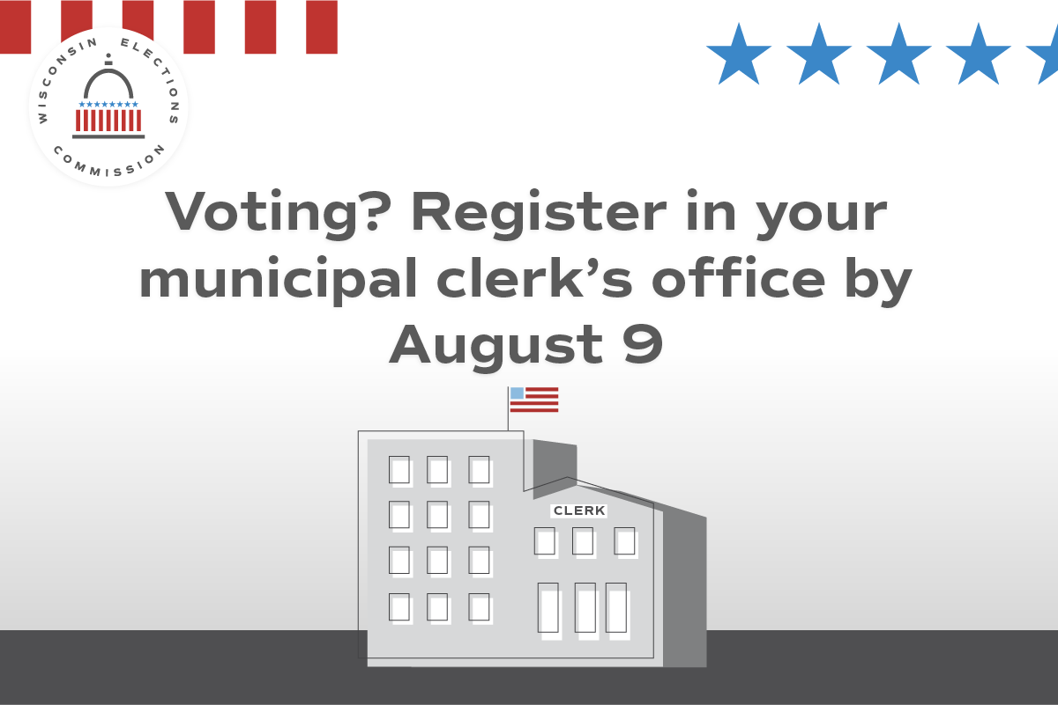  Missed the deadline to register to vote online or by mail? You can still register in our office by Aug. 9 or at your polling place on Aug. 13. Contact us at (CONTACT INFO HERE) to learn more about registering to vote.
IPAV | Use anytime | Cast your ballot before Election Day by voting an in-person absentee ballot at our office! Our hours are (INSERT HOURS/DATES OR BY APPOINTMENT INFO HERE).  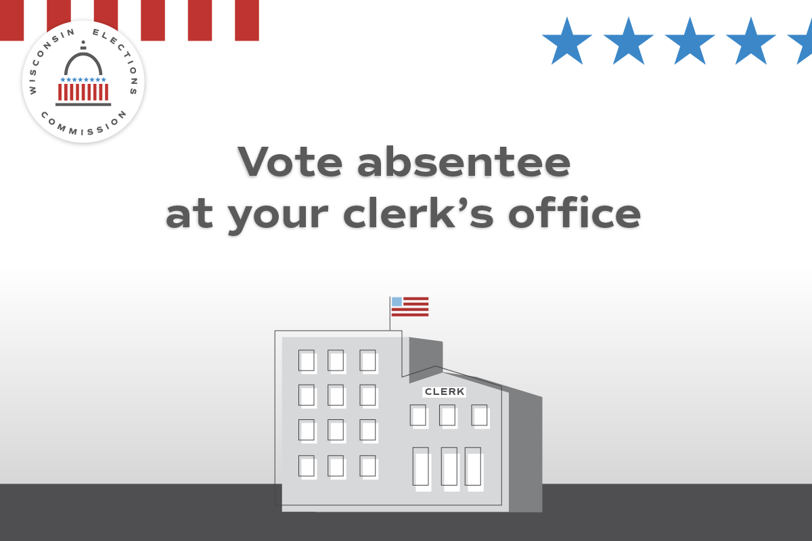
IPAV | Use anytime | Want to complete your ballot in person before Election Day? Vote an in-person absentee ballot! Starting [insert date for your community], any Wisconsin voter can visit (INSERT IPAV LOCATIONS HERE) and vote an in-person absentee ballot.  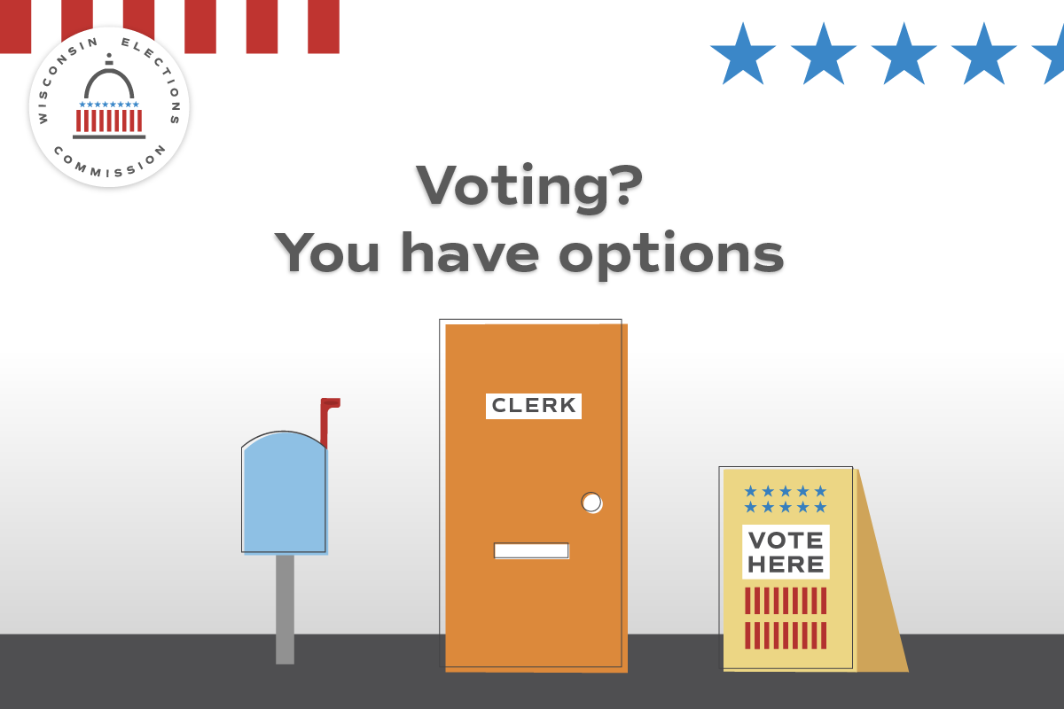
Absentee | Use by Aug. 6. | Finished filling out your absentee ballot? Don’t wait to mail it back or drop it off at (INSERT CLERK’S OFFICE)! All absentee ballots must arrive by 8 p.m. on Aug. 13 to be counted.
General Info | Use anytime | Do you know where your polling place will be for the Aug. 13 election? Confirm your polling place location at https://myvote.wi.gov/en-us/.
Photo ID | Use anytime | Your photo ID doesn’t need your current address. What ID will you use for the Aug. 13 Partisan Primary? https://bringit.wi.gov/  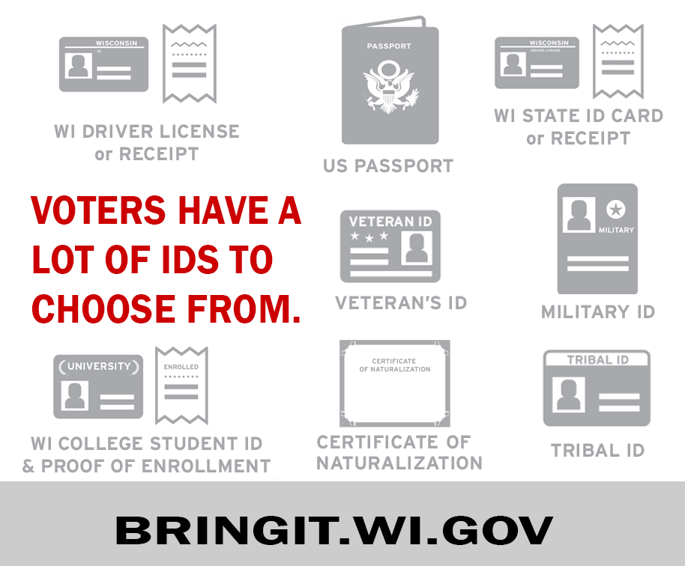
Poll Worker Recruitment | Promote as needed | Want to help your community and get paid? Serve as a poll worker! Contact our office at (CONTACT INFO HERE) to learn more.

July 28-August 3
Focus of the week – Focus on election security. IPAV. General election info.
Topic | Timing? | Suggested copy and image
Security | Use by Aug. 6 | Absentee voters must choose a witness — an adult U.S. citizen who can confirm the voter filled out their own ballot. Get the facts at https://elections.wi.gov/voters/voting-mail
Security | Use anytime | In Wisconsin, state and federal election results aren’t official until they’ve been reviewed at the local level, double-checked by county officials, and certified by the state. Find out more at https://elections.wi.gov/101  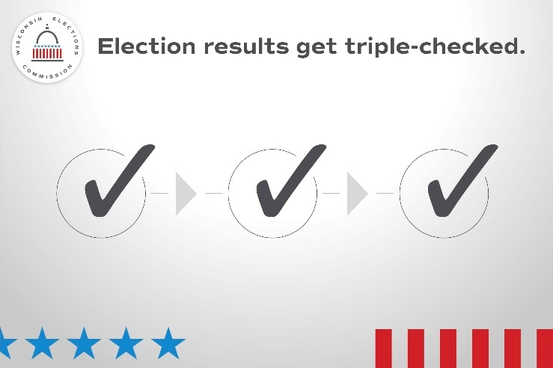
Security | Use anytime | In Wisconsin, only registered voters can request an absentee ballot. To make sure only eligible voters receive absentee ballots, local clerks are alerted when voters die or become ineligible https://elections.wi.gov/news-events/wisconsins-election-fact-checks  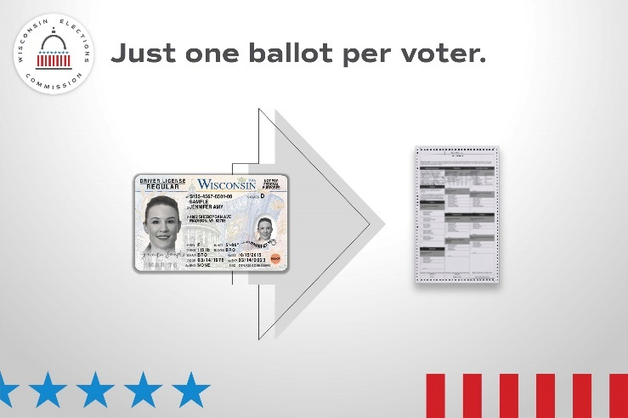
Photo ID | Use by July 30. | Whether you vote by absentee or at the polling place, you’ll need to provide a photo ID to vote. Visit https://bringit.wi.gov/ for more info about all the forms of ID accepted for voting, including how to get a free ID for voting!  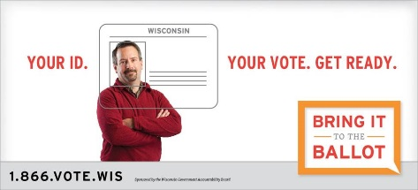
Absentee | Use by Aug. 6. | Finished filling out your absentee ballot? Don’t wait to mail it back! All absentee ballots must arrive by 8 p.m. on August 13 to be counted.
Absentee | Use by Aug. 6. | Don’t wait to mail back your absentee ballot. The USPS recommends mailing back your absentee ballot by Aug. 6 so it can arrive on Election Day. All ballots must be received by your local clerk by 8 p.m. on Election Day to count!  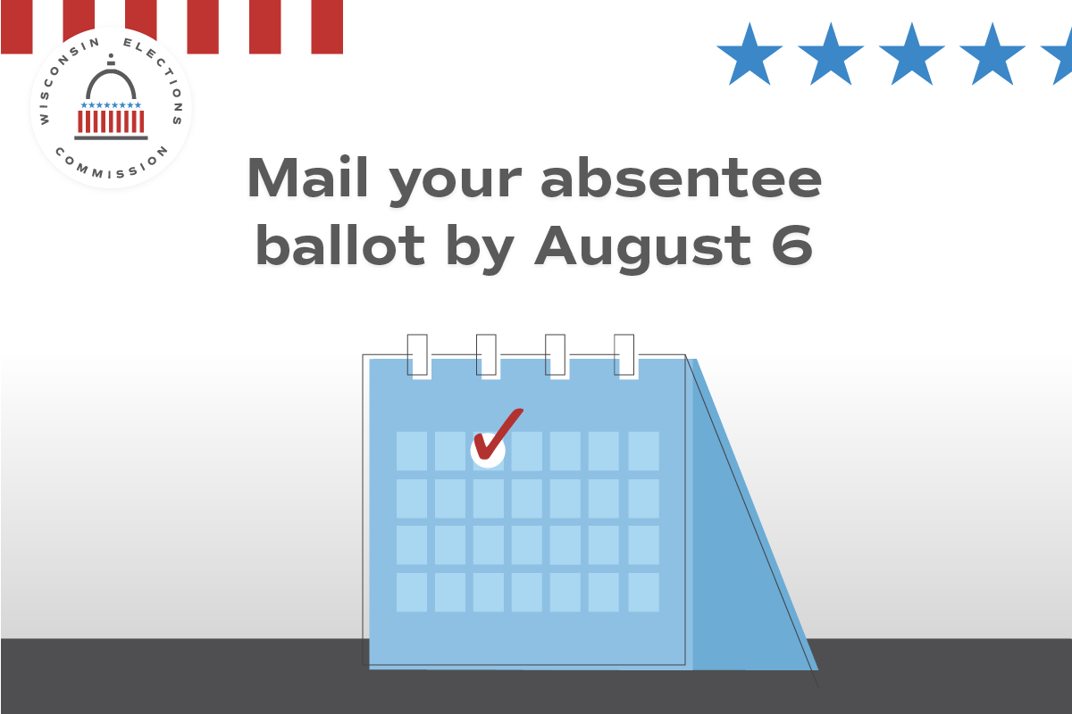
Equipment testing | Use before public test. | State law requires voting equipment be tested in public before each General Election. Want to observe the public test? Info is available here: (Insert link to local testing notice)  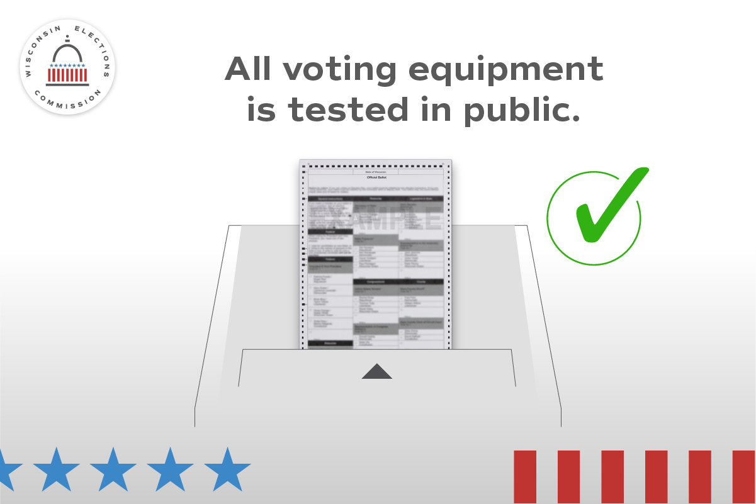
IPAV | Use multiple times by Aug. 11, the last day of IPAV | Cast your ballot before Election Day by voting an in-person absentee ballot at our office! Our hours are (INSERT HOURS OR BY APPOINTMENT INFO HERE).  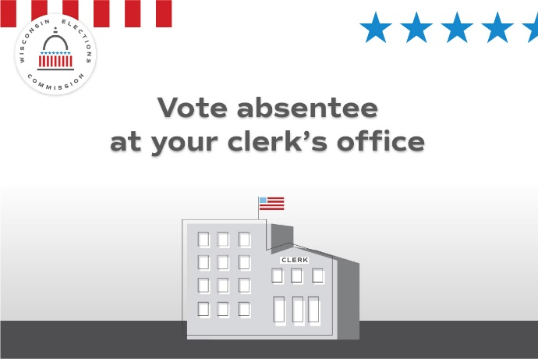
Poll Worker Recruitment | Promote as needed | Want to help your community and get paid? Serve as a poll worker! Contact our office at (CONTACT INFO HERE) to learn more.

August 4-12
Focus of the week – What will Election Day be like? Focus on election security. General election info.
Topic | Timing? | Suggested copy and image
Security | Use anytime | Interested in how Wisconsin runs elections? Visit https://elections.wi.gov/faq.  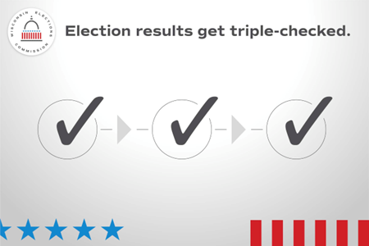
Security | Use anytime | In Wisconsin, state and federal election results aren’t official until they’ve been reviewed at the local level, double-checked by county officials, and certified by the state. Find out more at https://elections.wi.gov/101  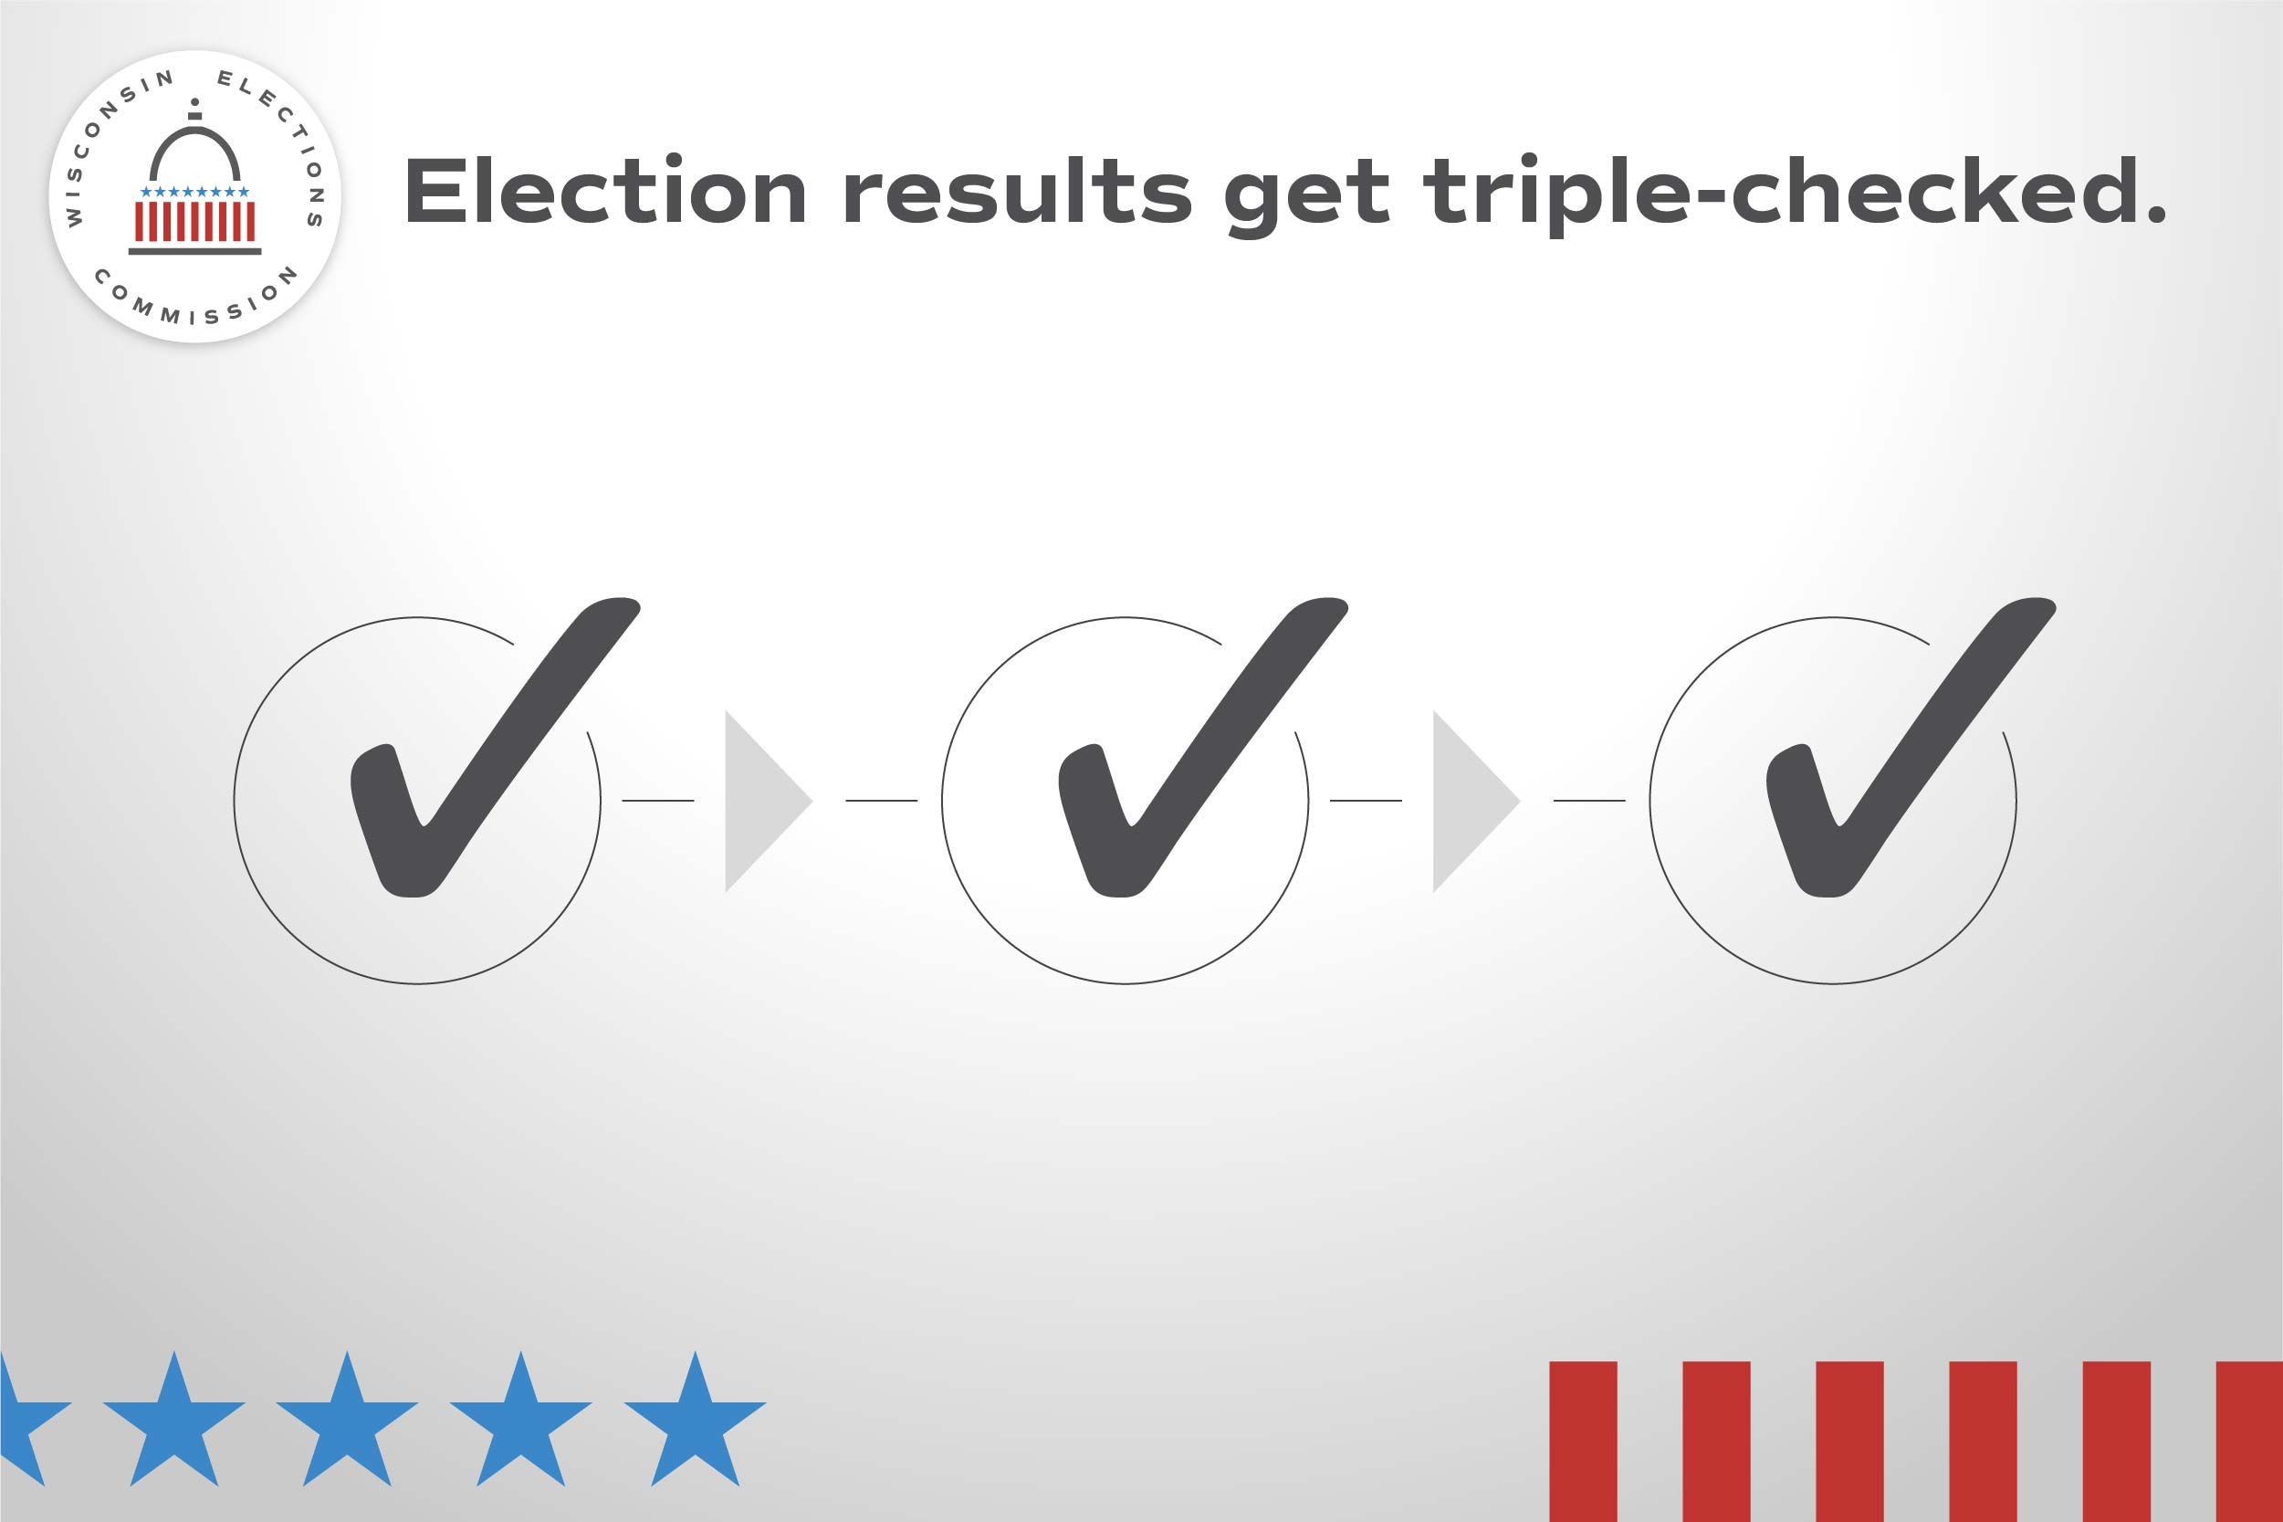
Security | Use anytime | Interested in how Wisconsin has improved how it runs elections? Visit https://elections.wi.gov/news-events/news
Absentee | Use Aug. 7-13. | Haven’t returned your absentee ballot yet? (INSERT ELECTION DAY RETURN INSTRUCTIONS) on Election Day. All absentee ballots must arrive by 8 p.m. on Aug. 13 to be counted.
Security | Use anytime | Wisconsin election officials are proactive, which is why local officials conduct two separate audits after WI elections to look for count inaccuracies and identify cases of voter ineligibility or fraud. https://elections.wi.gov/101
IPAV | Use by Aug. 11. | Cast your ballot before Election Day by voting an in-person absentee ballot at our office! Our hours are (INSERT HOURS OR BY APPOINTMENT INFO HERE).
Photo ID | Use anytime | Don’t have an ID for voting or docs like a birth certificate? Get a free ID for voting using the DMV’s ID Petition Process https://bringit.wi.gov/
Photo ID | Use by Aug. 12. | Don’t have the ID you need to vote for the Aug. 13 election? You can still vote a provisional ballot at the polls and then get an ID for free! https://myvote.wi.gov/en-us/Provisional-Ballots
Photo ID | Use anytime. | Don’t forget to bring your photo ID to the polls on August 13! Visit https://bringit.wi.gov/ for more info about all the forms of ID accepted for voting, including how to get a free ID for voting!
Photo ID | Use on Aug. 12 | Tomorrow is the Partisan Primary! Bring your photo ID to the polls and cast your ballot. Visit https://bringit.wi.gov/ to see more examples of the many kinds of photo ID.
General Info | Use by Aug. 12. | Get ready to vote on Tuesday, Aug. 13 by seeing what’s on your ballot. Visit https://myvote.wi.gov/en-us/ for more information.

August 13, Election Day
Focus of the week – General election info.
Topic | Timing? | Suggested copy and image
Election Day | Only use Aug. 13 | It’s Election Day! All polling places will be open from 7 a.m. until 8 p.m. Find your polling place at MyVote.wi.gov/en-us/FindMyPollingPlace  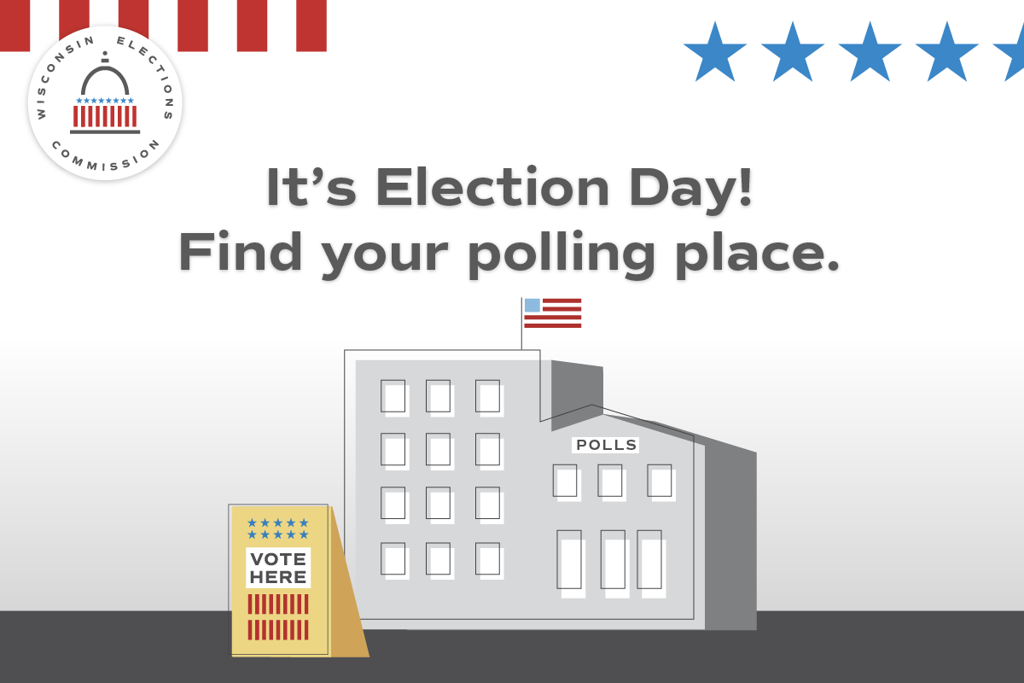
Election Day | Only use Aug. 13 | Still have your absentee ballot? Drop it off (CLERK INSERT BALLOT RETURN LANGUAGE)!  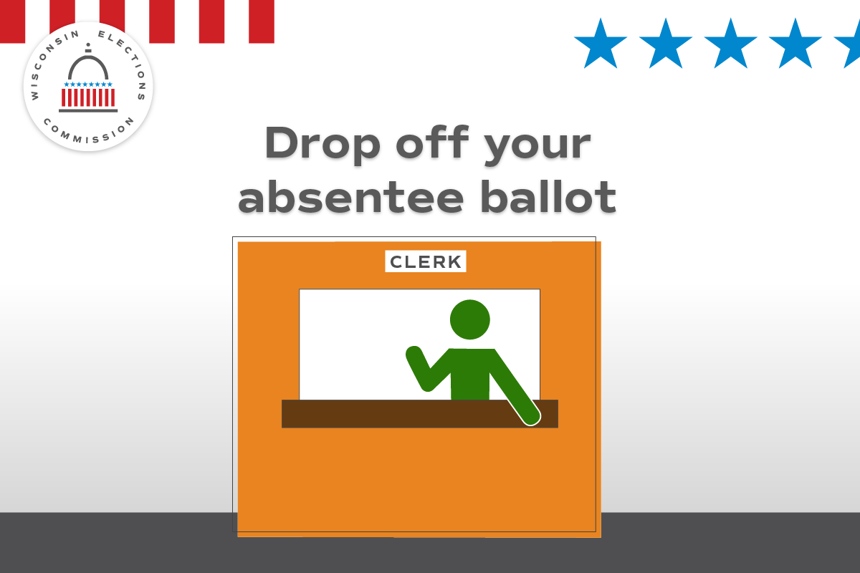
Election Day | Only use Aug. 13 | Your photo ID doesn’t need your current address. https://bringit.wi.gov/  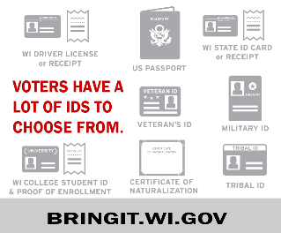

General Posts to be Used Anytime
Use these social media posts whenever time allows.
Topic | Timing? | Suggested copy and image
Security | Use anytime | Every vote has a paper trail. Wisconsin requires a paper record of every vote cast, no matter what kind of ballot or voting equipment is used. https://elections.wi.gov/101  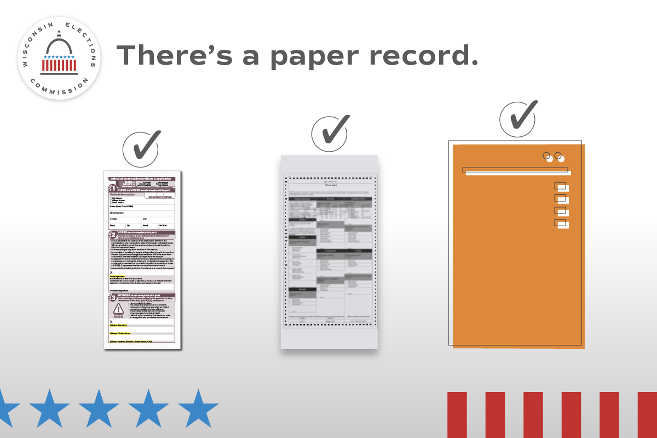
Photo ID | Use anytime, preferably with plenty of time before Election Day | Interested in getting a free ID for voting purposes? Visit https://bringit.wi.gov/ for more information and to get ready for August 13!  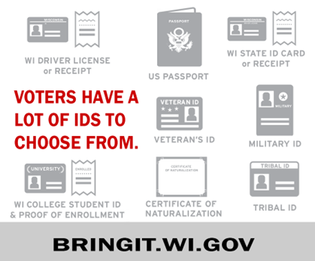
Absentee | Use by Aug. 6. | When voting absentee, pay close attention to the included instructions. Make sure your voter information is correct, that you've signed, and that your witness has provided the required information. Learn more at https://myvote.wi.gov/en-us/Vote-Absentee-guide  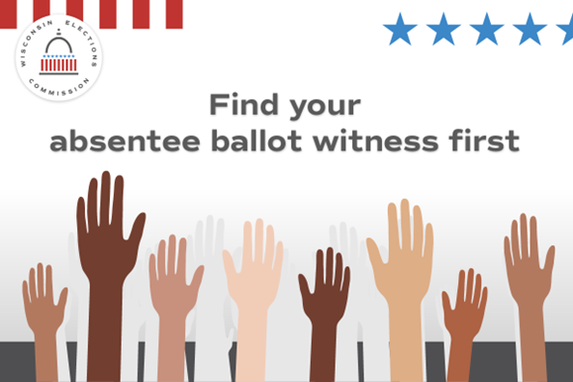
Absentee | Use by July 30 | Voting in the August 13 Partisan Primary? Choose the option that’s right for you: at the polls; absentee by mail; or absentee in person. https://myvote.wi.gov/en-us/
Photo ID | Use anytime, preferably with plenty of time before Election Day. | Don’t have an ID for voting or docs like a birth certificate? Get a free ID for voting using the DMV’s ID Petition Process https://elections.wi.gov/photoid  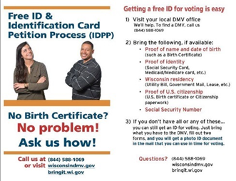
General info | Use by July 24. | Not sure where your polling place is? Need to get re-registered? Visit https://myvote.wi.gov/en-us/ for all your election needs!
General info | Use anytime | See the absentee and registration deadlines for the August 13 Partisan Primary at MyVote.wi.gov/en-us/VoterDeadlines
Photo ID | Use anytime | Your photo ID doesn’t need your current address. What ID will you use for the August 13 Partisan Primary? https://elections.wi.gov/photoid
Poll Worker Recruitment | Promote as needed. | Want to help your community and get paid? Serve as a poll worker! Contact our office at (CONTACT INFO HERE) to learn more.

