Social Media Calendar for General Election on Nov. 5
Posts for Week of Sept. 22-28, plus Sept. 17, National Voter Registration Day
Focus of the week – Q&A about voting absentee, registration, general election info, what to do with absentees.
Topic | Timing? | Suggested copy and image
National Voter Registration Day | Use ONLY on Sept. 17 | Happy #NationalVoterRegistrationDay!  Get ready for Nov. 5 by visiting MyVote.wi.gov, where you can check your registration status and register to vote online. If you recently moved, changed your name, or haven’t registered to vote before, take a few minutes to get registered!  
Registration | Use until Oct. 16 | Before casting a ballot in the November General Election, you must be registered to vote. If you have an up-to-date WI driver license or ID you can register online at https://myvote.wi.gov/en-us/ by Oct. 16.  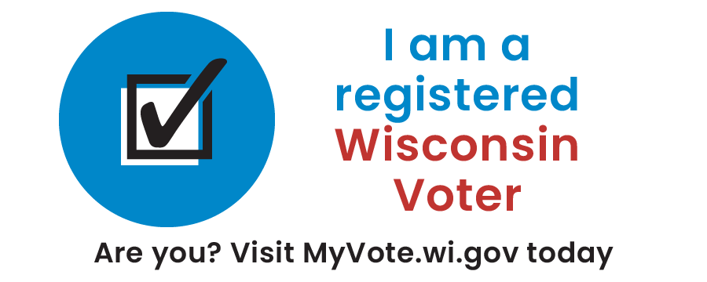
Absentee/MyVote | Use until Oct. 16 | Registered, eligible WI voters can use https://myvote.wi.gov/en-us/ to request an absentee ballot and submit a copy of their acceptable photo ID.  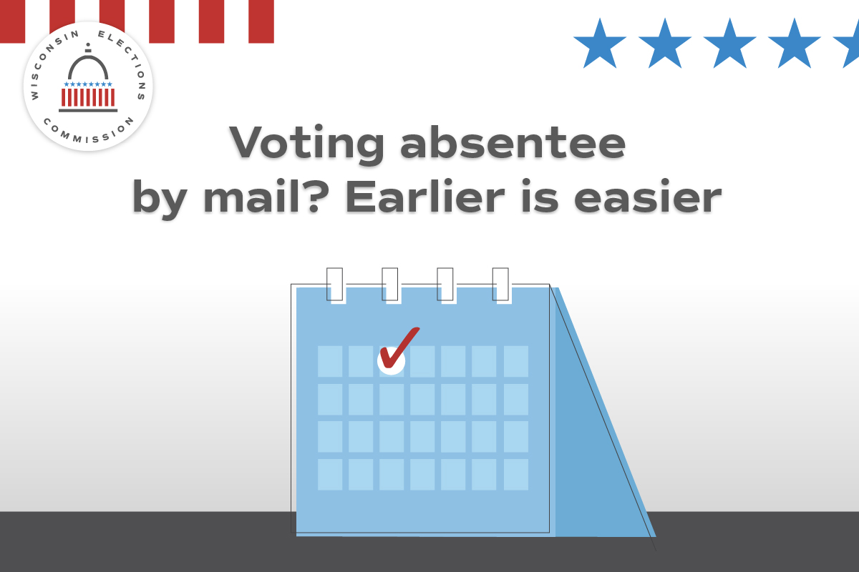

Absentee/MyVote | Use by Oct. 22 | Registered, eligible WI voters can request an absentee ballot by mail at https://myvote.wi.gov/en-us/. Act now to vote by mail for the November General Election.  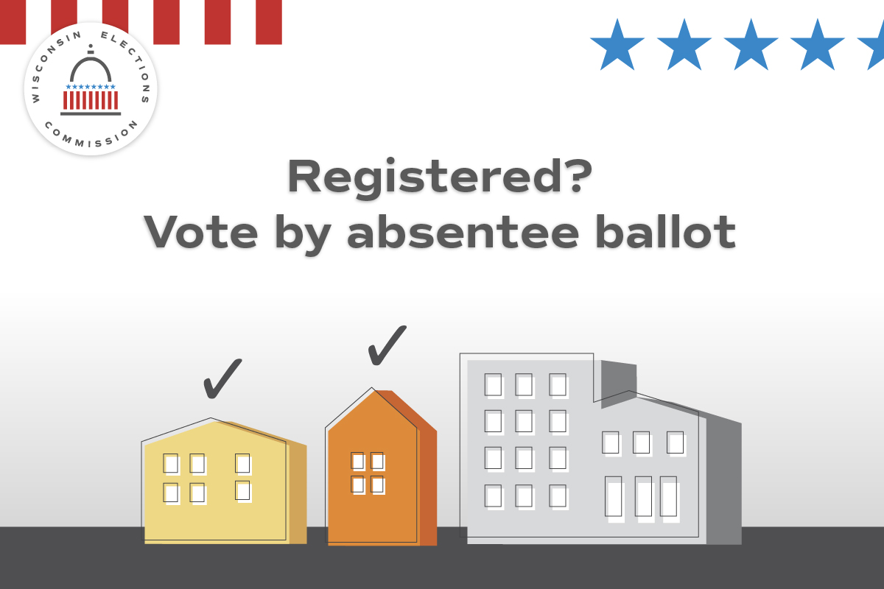
Voting options | Use through Oct. 16 | Voting in the November General Election? Choose the option that’s right for you: at the polls; absentee by mail; or absentee in person. Visit https://myvote.wi.gov/en-us/ to learn more.  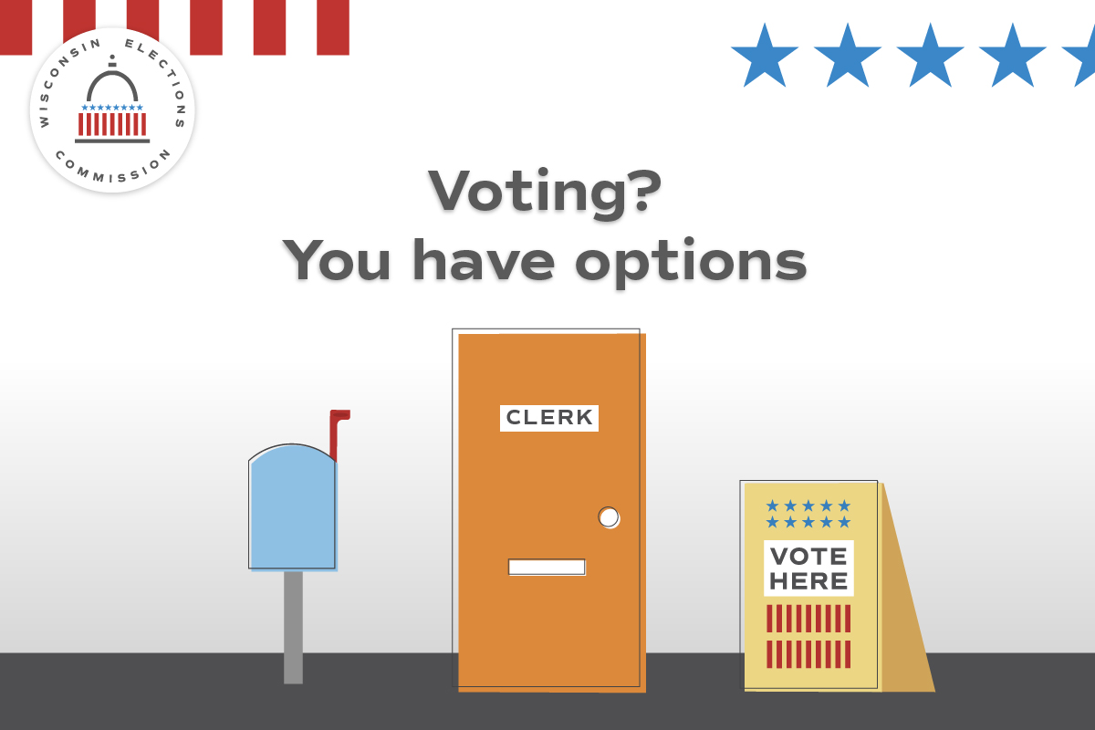

Absentee/MyVote | Use through Oct. 16 | Registered, eligible WI voters can request an absentee ballot for the Nov. 5 General Election at https://myvote.wi.gov/en-us/! Absentee ballots must arrive by 8 p.m. on Election Day.  
Registration/MyVote | Use as needed | The General Election is Nov. 5! Are you registered to vote? Visit https://myvote.wi.gov/en-us/ and confirm your registration is up-to-date today.  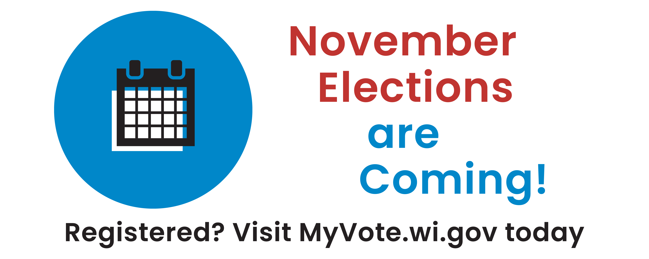
Photo ID | Use anytime | Whether you vote at the polls or by absentee, you’ll need to provide an acceptable photo ID. Visit https://elections.wi.gov/photoid for more info about accepted ID forms, including how to get a free ID for voting!  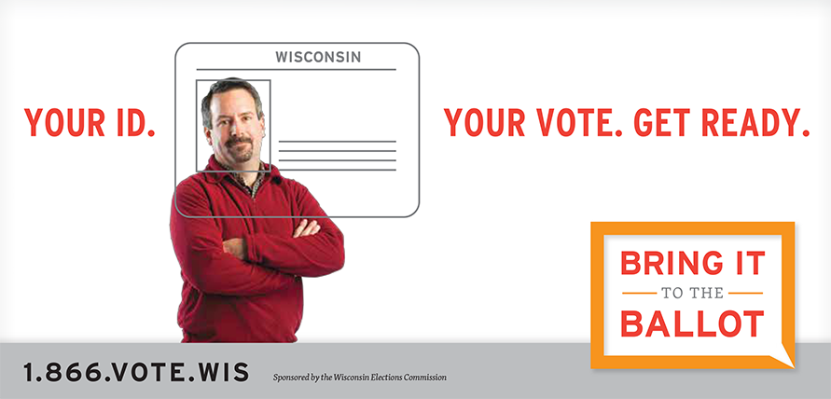

Witness | Use by Oct. 29 | If you’re voting absentee by mail for the November General Election, remember you’ll need a witness. Your witness can be your spouse, neighbor, or another adult U.S. citizen. Learn more at https://myvote.wi.gov/en-us/Vote-Absentee-By-Mail!  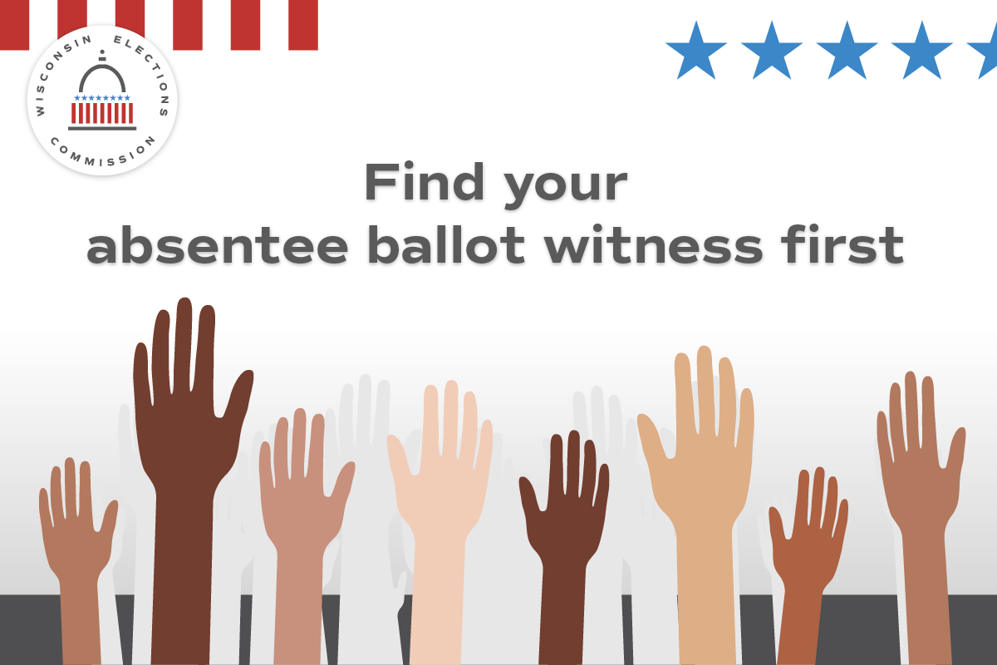

Registration | Use by Oct. 16 | If you’ve moved or changed your name, you must re-register to vote. If you have an up-to-date WI driver license or ID you can register at https://myvote.wi.gov/en-us/.  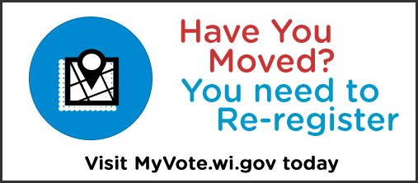
Absentee | Use by Oct. 29 | Finished filling out your absentee ballot? Mail it back at least one week before Election Day to ensure it arrives on time.  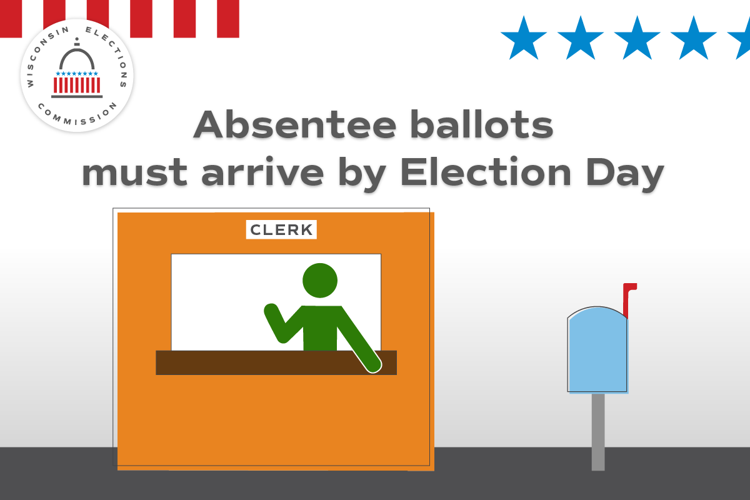
Photo ID | Use anytime | Don’t have an ID for voting or docs like a birth certificate? Get a free ID for voting using the DMV’s ID Petition Process. https://bringit.wi.gov/  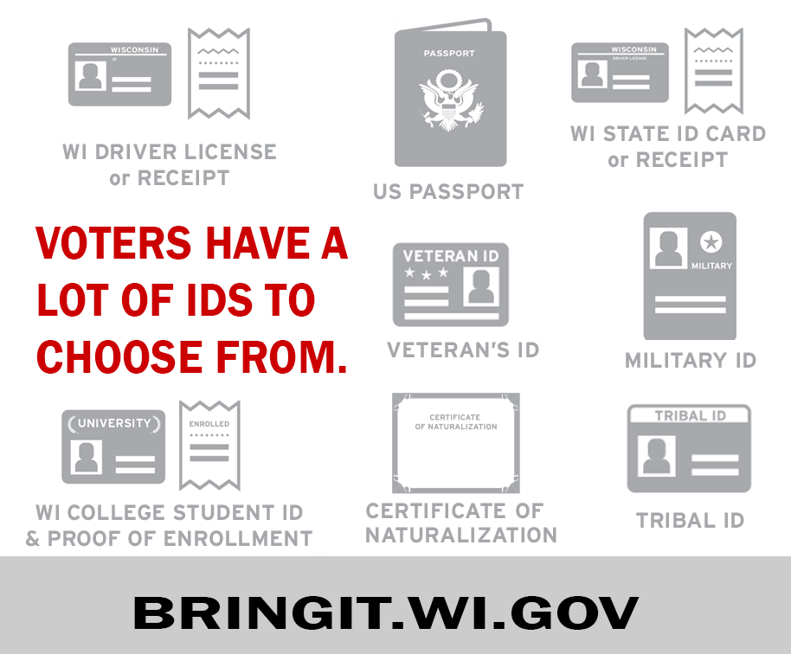

Sept. 29-Oct. 5
Focus of the week – General election info.
Topic | Timing? | Suggested copy and image
General info | Use ONLY on Oct. 5 | Only one month until Election Day! Do you have a plan to vote? Confirm your registration, request your absentee ballot, or find your polling place all at https://myvote.wi.gov/en-us/!  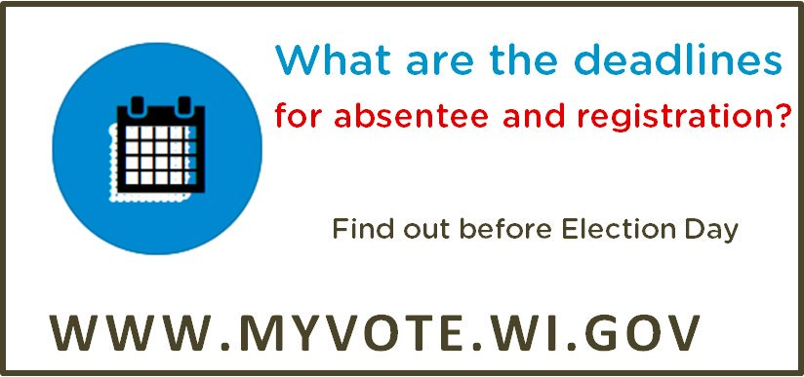
Registration | Use through Oct. 16 | Oct. 16 is the last day to register to vote online for the Nov. 5 General Election! Start or update your registration at https://myvote.wi.gov/en-us/. If you miss it, you can still register in your clerk’s office or at your polling place on Election Day.  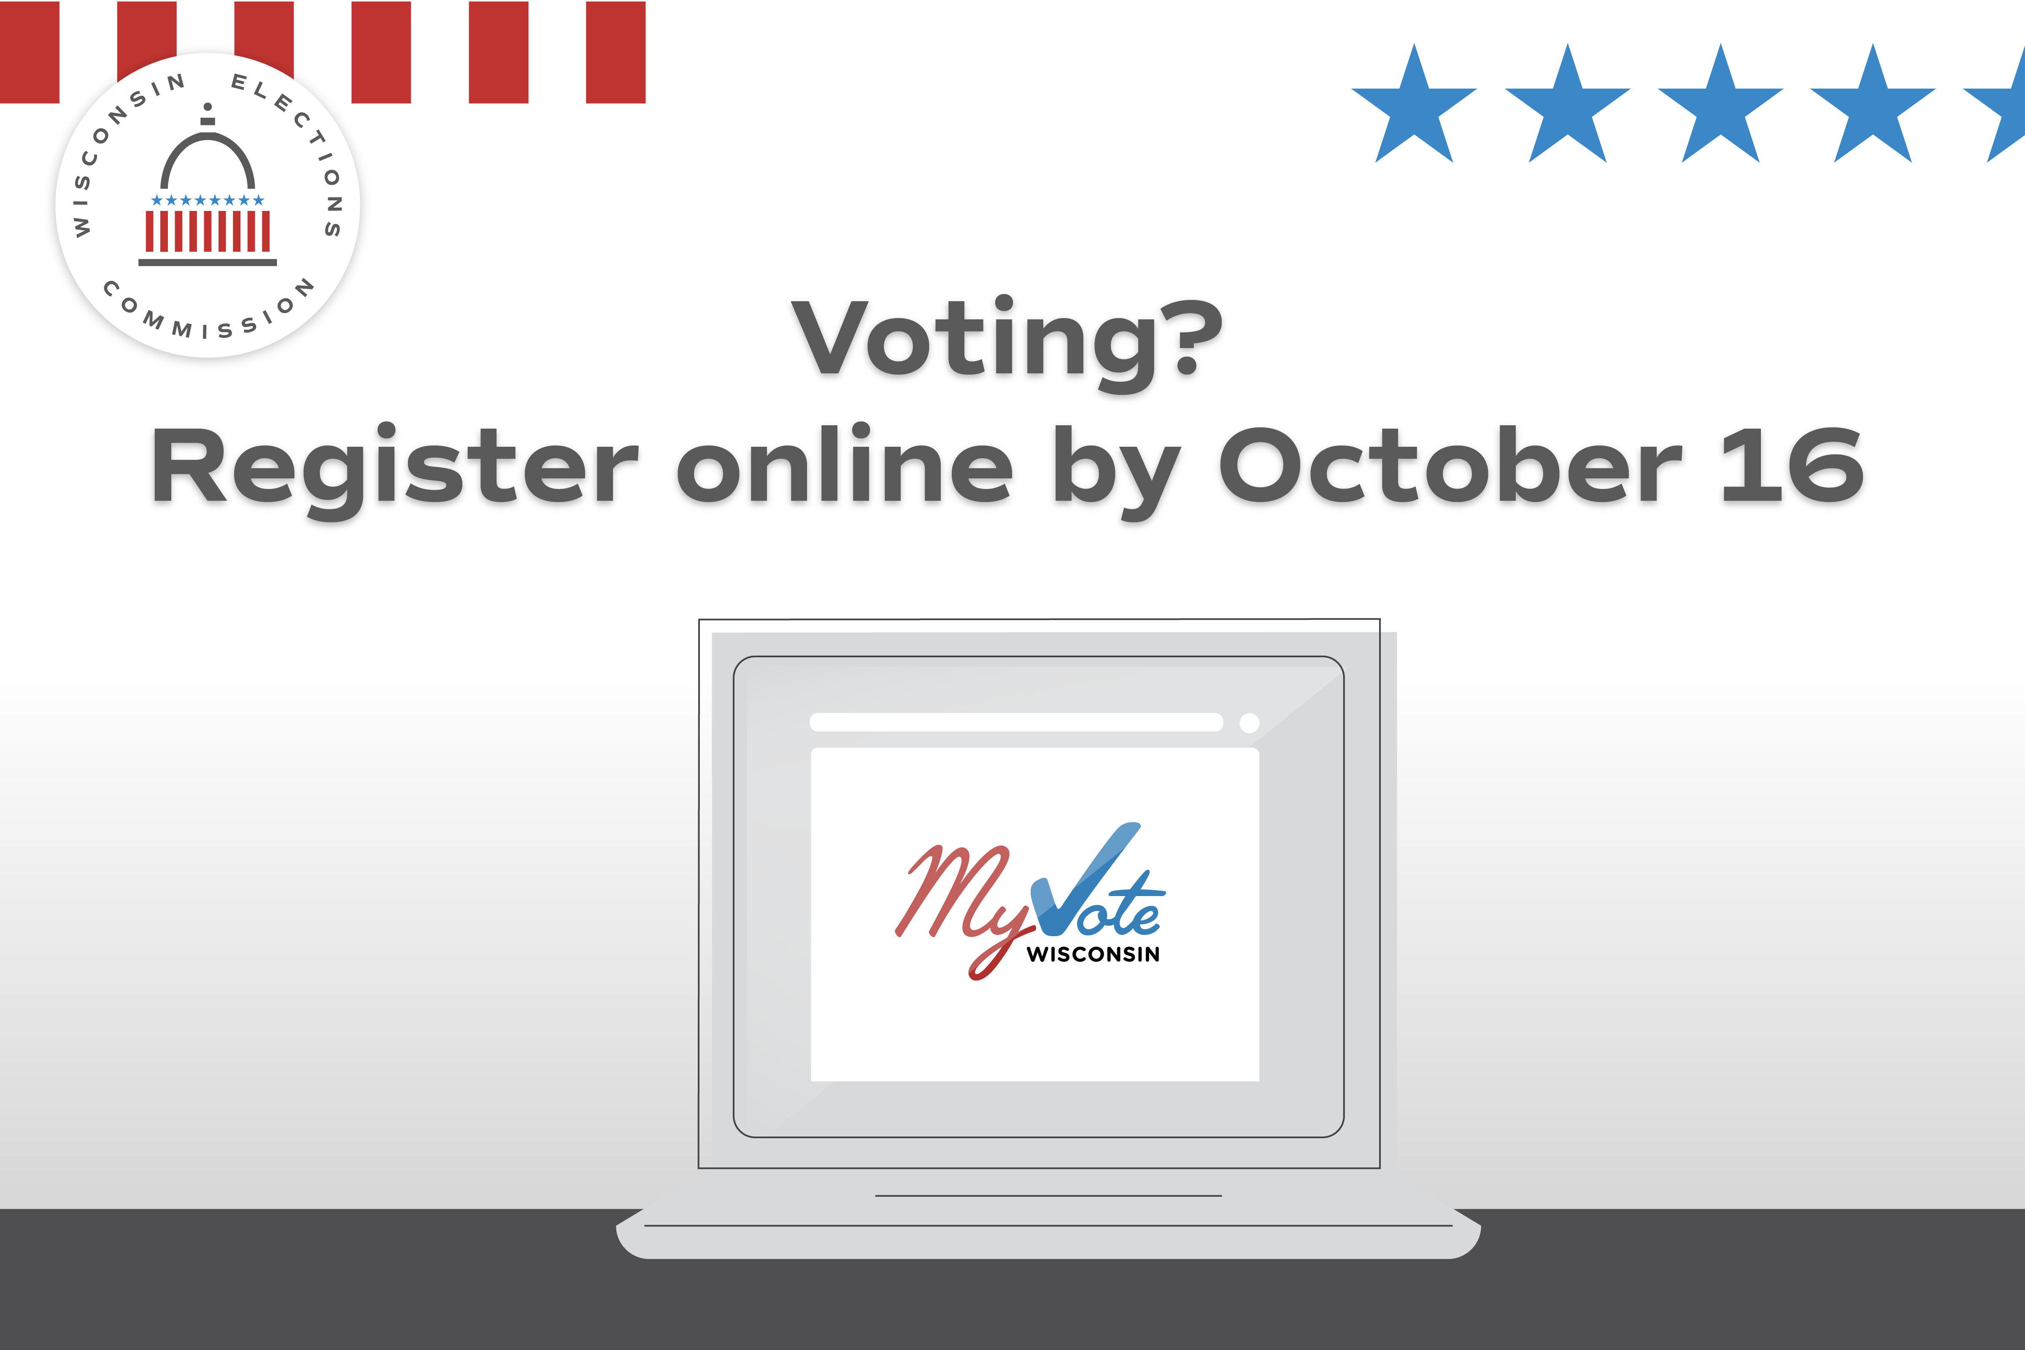
Witness | Use on or before Oct. 29 | If you’re voting absentee by mail, remember you’ll need a witness. This person could be your spouse, neighbor, friend, or any adult U.S. citizen. Learn more at https://myvote.wi.gov/en-us/Vote-Absentee-By-Mail.
Absentee | Use anytime through Oct. 29 | Mailing in your absentee ballot is easy. Just remember to do it early! Your ballot must arrive by Election Day to be counted.
Poll Worker Recruitment | Promote as needed | Want to help your community and get paid? Serve as a poll worker! Contact our office at (LOCAL CONTACT INFO HERE) to learn more. You can also find your local clerk at https://myvote.wi.gov/en-us/.  
Photo ID | Use by Nov. 3, deadline for IPAV | Your photo ID for voting doesn’t need to have your current address. What ID will you use for your absentee ballot request or at the polls on Nov. 5? Visit https://elections.wi.gov/photoid
IPAV | Use by close of your municipality’s IPAV offerings | Want to vote in the November General Election using an in-person absentee ballot? You can, starting on [INSERT DATE]. Learn more at https://myvote.wi.gov/en-us/Vote-Absentee-In-Person

Oct. 6-12
Focus of the week – In person absentee voting reminders. Online registration deadline. General election info.
Topic | Timing? | Suggested copy and image
IPAV | Use this week as a reminder | Want to cast your ballot in person before Election Day? You can by casting an in-person absentee ballot! This option is offered (INSERT HOURS/DATES OR BY APPOINTMENT INFO HERE).  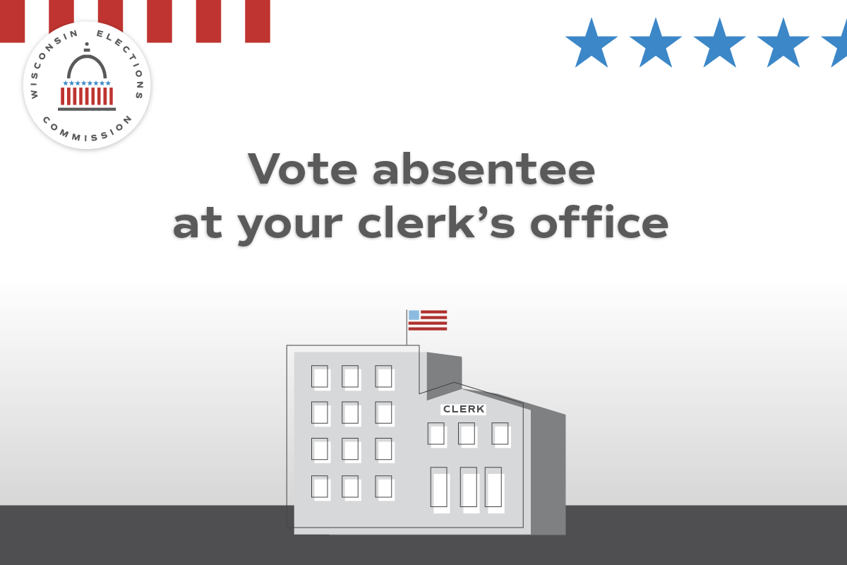
General Info | Use anytime | Do you know where your polling place will be for the November General Election? Confirm your polling place location at https://myvote.wi.gov/en-us/.  
Photo ID | Use anytime | Your photo ID doesn’t need your current address. What ID will you use for the November General Election? https://elections.wi.gov/photoid  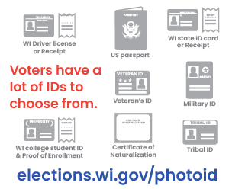
Poll Worker Recruitment | Promote as needed | Want to help your community and get paid? Serve as a poll worker! Contact our office at (CONTACT INFO HERE) to learn more.
Disability Rights | Use anytime (tailor to options available in your municipality) | An absentee ballot must be placed in the mail, or the voter must personally deliver it to the municipal clerk (add appropriate return locations)  Voters who need assistance due to disability can select someone (except an employer or union rep) to return the ballot.  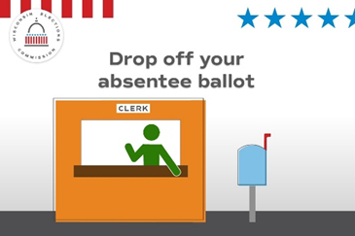
Disability Rights | Use anytime | Voters with disabilities have options when casting a ballot. Voters who need assistance due to disability can select someone (except their employer or union rep) to return their absentee ballot. They also have the right to assistance at the polling place.  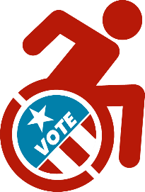

Oct. 13-19
Focus of the week – Focus on election security. IPAV. General election info.
Topic | Timing? | Suggested copy and image
Online voter registration deadline | Use ONLY on October 15 | TOMORROW is the last day to register to vote online or by mail for Nov. 5! Start or update your registration at https://myvote.wi.gov/en-us/. After today, you can still register at our office until [insert your municipality’s deadline] or at the polls on Election Day.  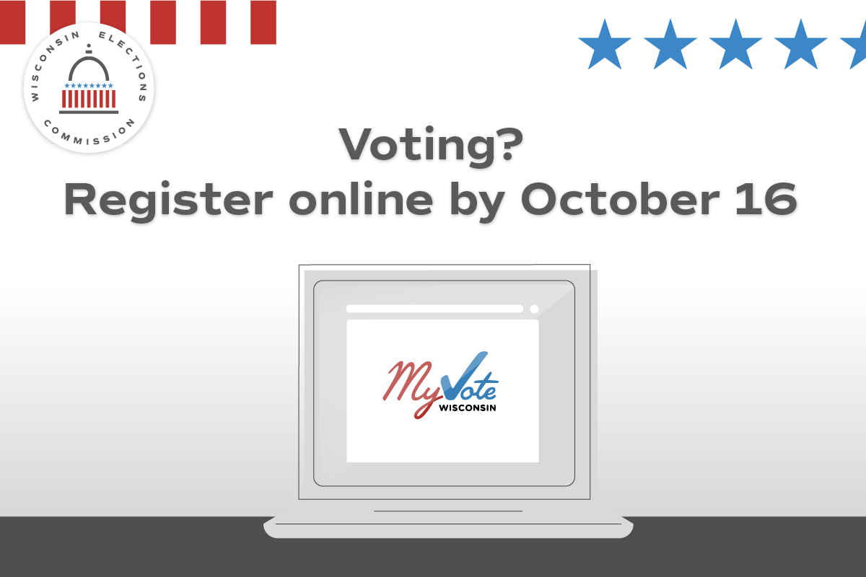
Online voter registration deadline | Use ONLY on October 16 | TODAY is the last day to register to vote online or by mail for Nov. 5! Start or update your registration at https://myvote.wi.gov/en-us/. After today, you can still register in our office until [insert your municipality’s deadline] or at the polls on Election Day.
Registration | Use Oct. 16-31 | Missed the deadline to register to vote online or by mail? You can still register in our office by [insert your municipality’s deadline] or at your polling place on Nov. 5!  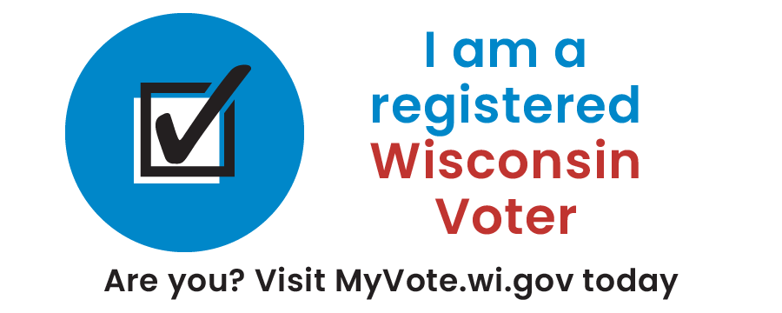
Security | Use until Oct. 29 | Absentee voters must choose a witness — an adult U.S. citizen who can confirm the voter filled out their own ballot. Get the facts at https://elections.wi.gov/voters/voting-mail
Security | Use anytime | In Wisconsin, only eligible, registered voters can request an absentee ballot. Local clerks verify each voter meets these standards and are alerted when voters die or become ineligible https://elections.wi.gov/news-events/wisconsins-election-fact-checks  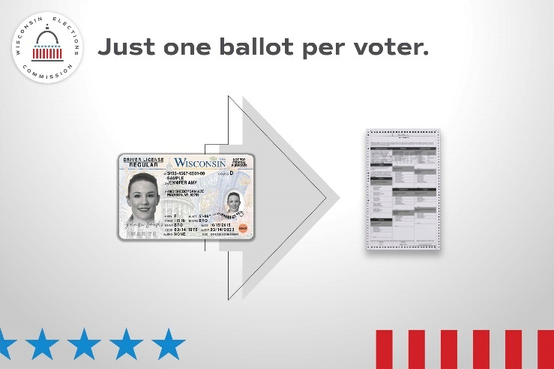
Equipment testing | Use before first public test date, which is Oct. 26. | State law requires voting equipment be tested in public before each General Election. Want to observe the public test? Info is available here: (Insert link to local testing notice)  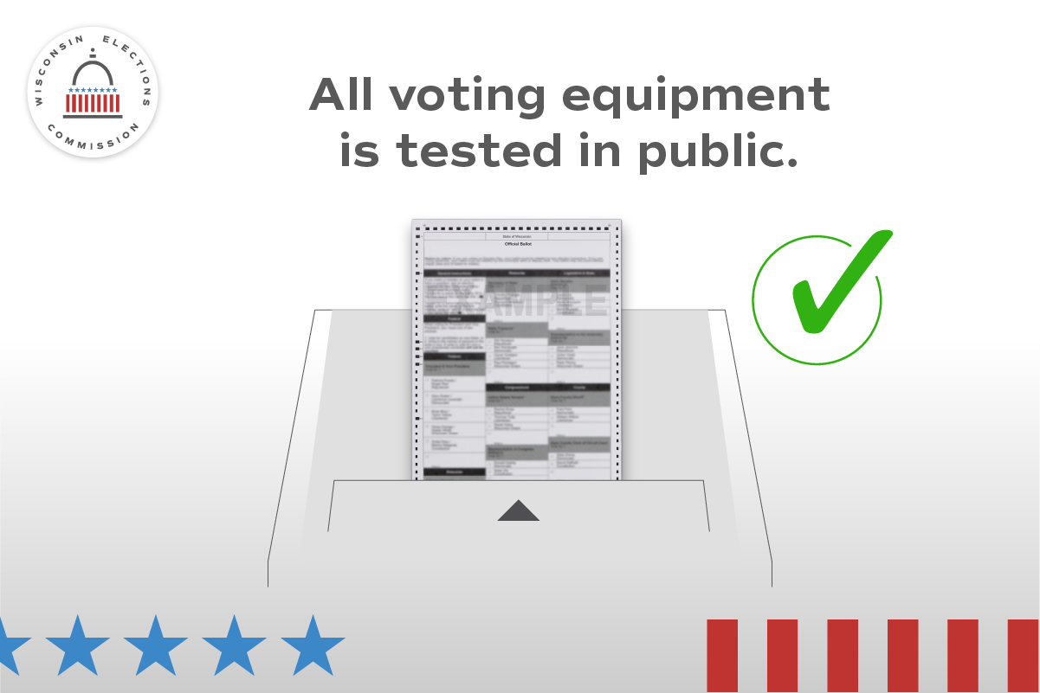
IPAV | Use anytime as a reminder | You can soon cast your ballot before Election Day by voting an in-person absentee ballot at our office! Our hours will be (INSERT HOURS OR BY APPOINTMENT INFO HERE).  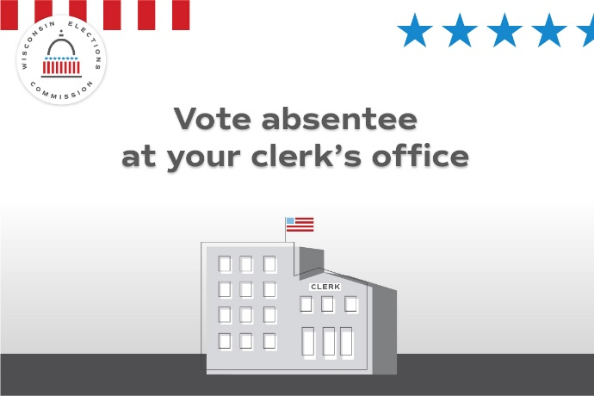
Poll Worker Recruitment | Promote as needed | Want to help your community and get paid? Serve as a poll worker! Contact our office at (CONTACT INFO HERE) to learn more.
Absentee | Use anytime | We strongly recommend mailing your absentee ballot back at least one week before the election. All ballots must be received by 8 p.m. on Election Day to count!  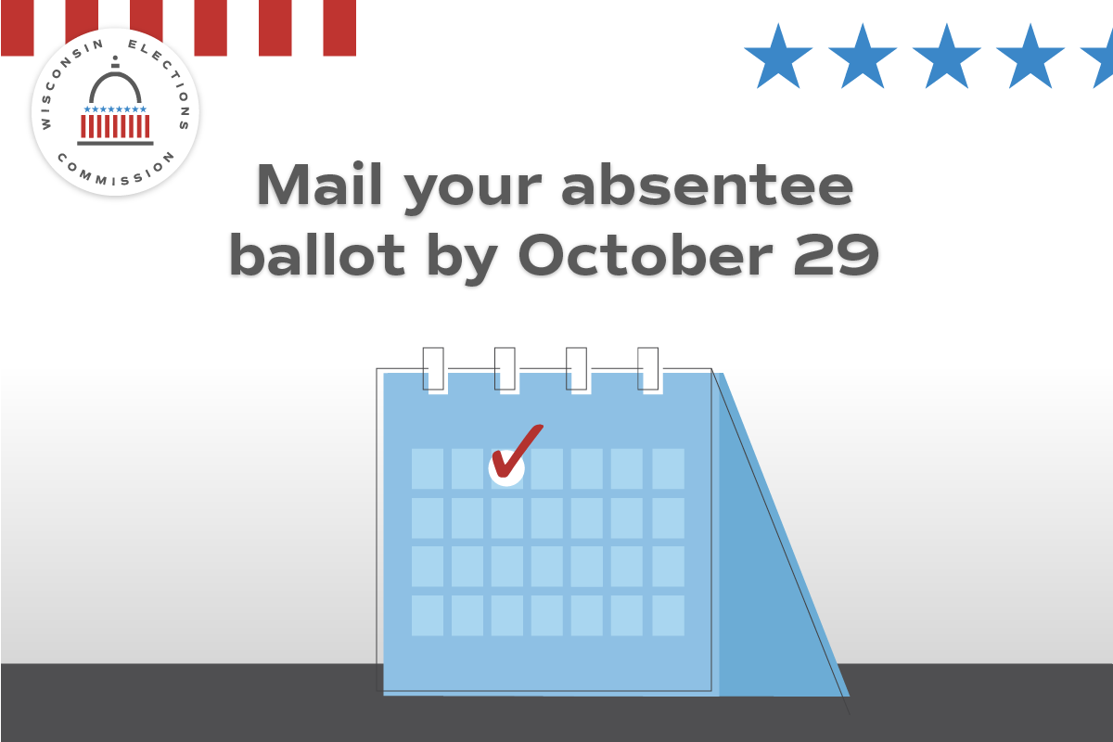

Oct. 20-26
Focus of the week – What will Election Day be like? Focus on election security. General election info. IPAV.
Topic | Timing? | Suggested copy and image
IPAV | Use during your IPAV as many times as needed | In-person absentee voting is under way! Come cast your ballot in person before Election Day (insert hours/location info here).  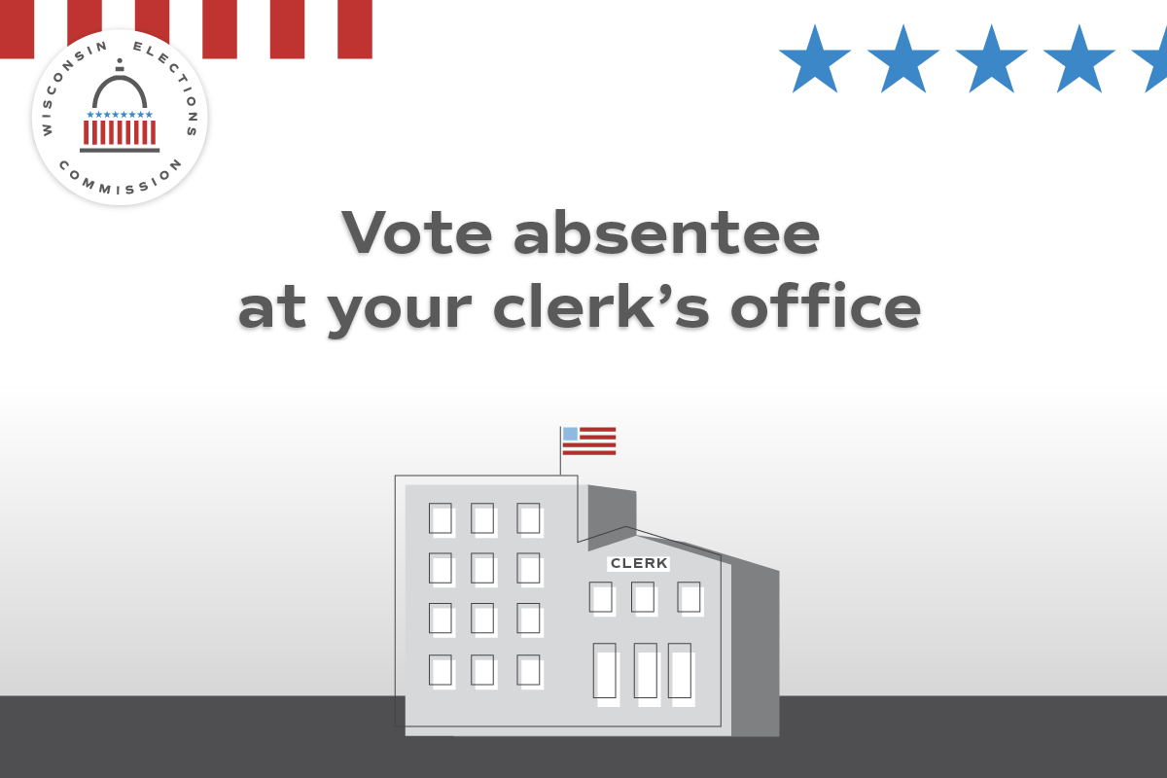
Photo ID | Use anytime | Don’t forget to bring your photo ID to the polls on Nov. 5! Visit elections.wi.gov/photoid for more info about all the forms of ID accepted for voting, including how to get a free ID for voting!
General Info | Use anytime. Repeat Week of Oct. 27. | Get ready to vote on Tuesday, Nov. 5 by seeing what’s on your ballot. Visit https://myvote.wi.gov/en-us/ for more info.  
Security | Use anytime | Interested in how Wisconsin runs elections? Visit https://elections.wi.gov/faq.  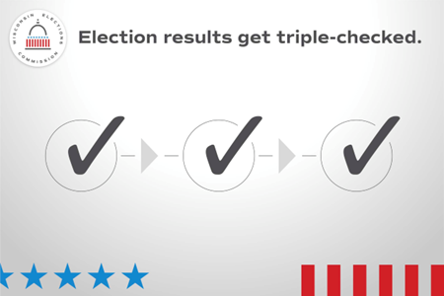
Absentee | Use this week as reminder | Haven’t returned your absentee ballot yet? Do so as soon as you can! All absentee ballots must arrive by 8 p.m. on Nov. 5 to be counted. (Insert applicable absentee return instructions).
Photo ID | Use anytime | Don’t have the ID you need to vote on Nov. 5? You can still vote a provisional ballot at the polls and then get an ID for free! https://bringit.wi.gov/how-do-i-get-free-state-id-card
Registration | Use by Nov. 1 or your municipality’s in person registration deadline | (Insert Day) is the last day to register to vote in our office for the Nov. 5 election! (Insert hours/locations)  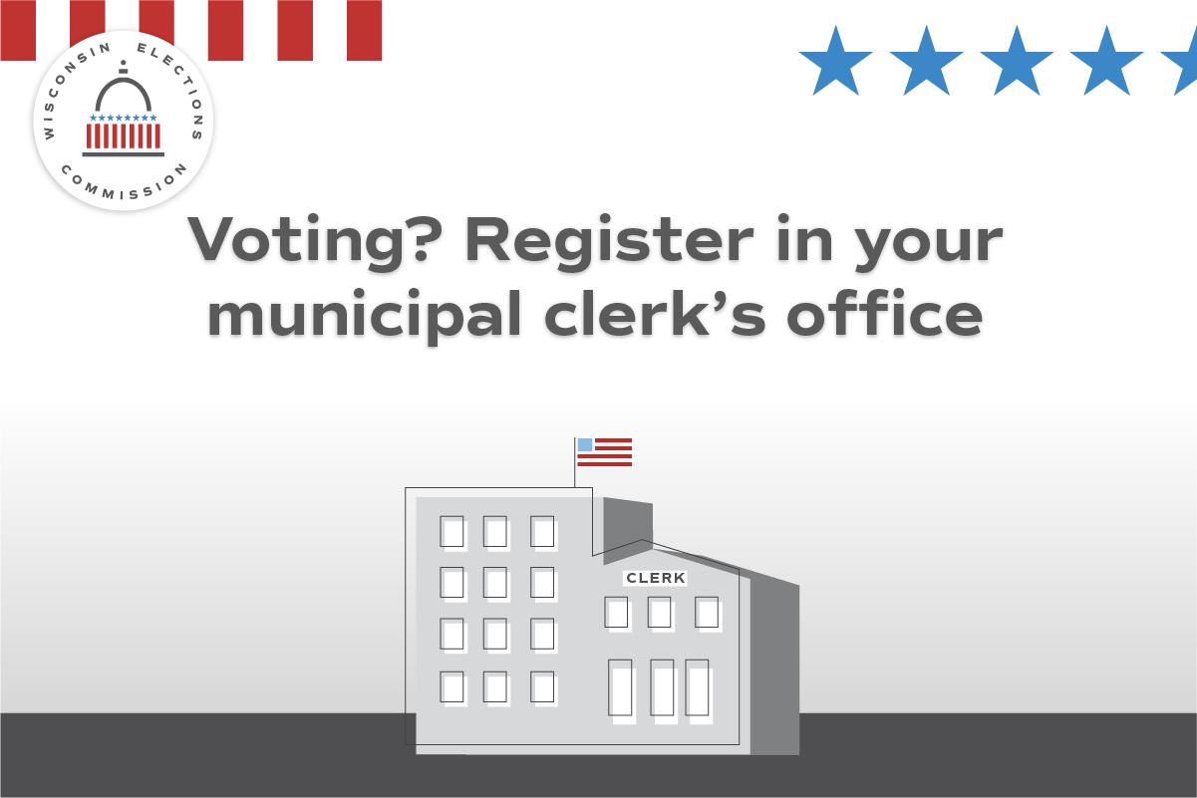
Public Test of Voting Equipment | Use to promote public test | State law requires voting equipment be tested in public before each General Election. Come see the test for yourself! Info is available here: (Insert link to local testing notice)

Oct. 27-Nov. 4
General info, plus final reminders on things like photo ID and absentee voting.
Topic | Timing? | Suggested copy and image
Registration | Use on last day of in person registration in your municipality | TODAY is the last day to register to vote in our office for the Nov. 5 election! Stop by (insert hours/locations). After today, you can still register at the polls on Nov. 5.
Photo ID | Use anytime | Don’t forget to bring your photo ID to the polls on Nov. 5! Visit https://bringit.wi.gov/ for more info about all the forms of ID accepted for voting, including how to get a free ID for voting!  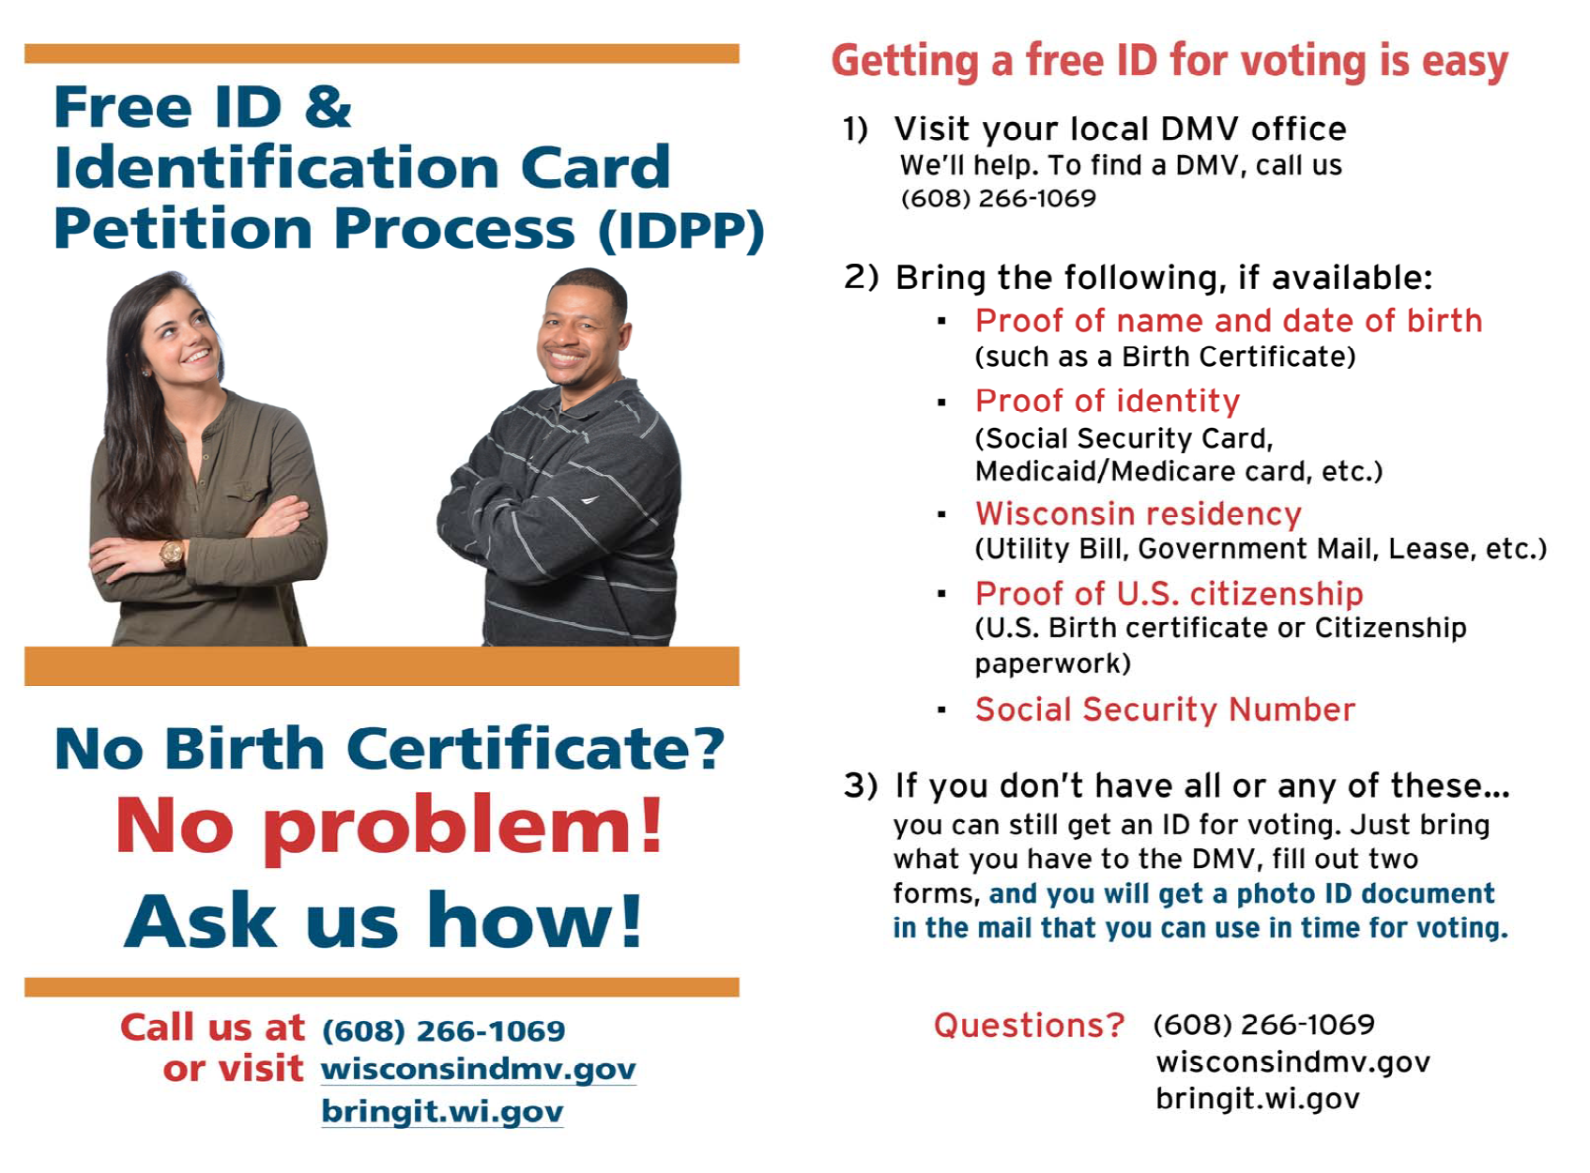
General info | Use by Nov. 1, the deadline to register in the clerk’s office | Not sure where your polling place is? Need to see if you’re registered? Visit https://myvote.wi.gov/en-us/ to get ready for Nov. 5!
Photo ID | Use ONLY on Nov. 4 | Tomorrow is the General Election! Bring your photo ID to the polls and cast your ballot. Visit https://elections.wi.gov/photoid to see more examples of the many kinds of photo ID.
Absentee | Use from Oct. 30 to Nov. 4 | Haven’t returned your absentee ballot yet? It may be too late to mail it back. Instead, you can drop it off (insert drop off instructions). Absentee ballots must arrive by 8 p.m. on Nov. 5 to be counted.  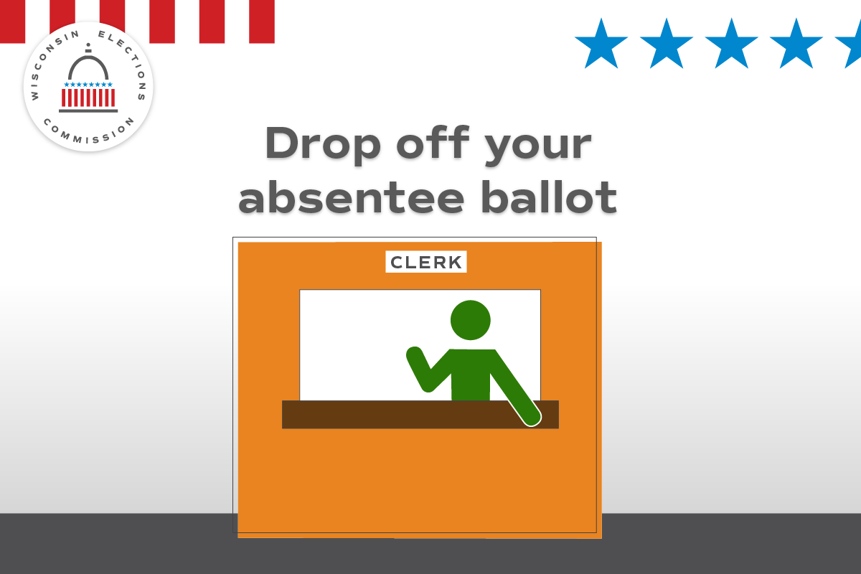
Photo ID | Anytime | Your photo ID doesn’t need your current address. What ID will you use at the polls on Nov. 5? https://elections.wi.gov/photoid

Nov. 5, Election Day
Focus of the week – General election info.
Topic | Timing? | Suggested copy and image
Election Day | Use ONLY on Nov. 5 | It’s Election Day! All polling places will be open from 7 a.m. until 8 p.m. Find your polling place at MyVote.wi.gov/en-us/FindMyPollingPlace  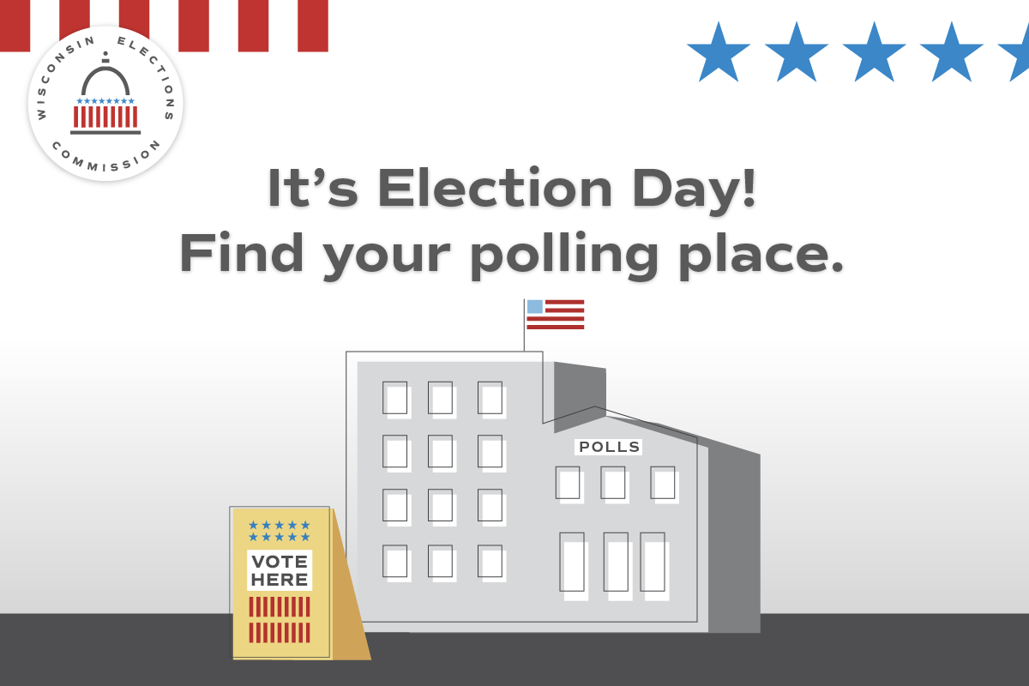
Election Day | Use ONLY on Nov. 5 | Still have your absentee ballot? Drop it off today! (CLERK INSERT BALLOT RETURN LANGUAGE)

