Spring Primary 2023 Suggested Social Media Posts
Topic | Timing | Suggested copy and image
Photo ID | Use any time | Interested in getting a free ID for voting purposes? Visit http://bit.ly/3Dj48EQ for more information and to get ready for Feb. 21!  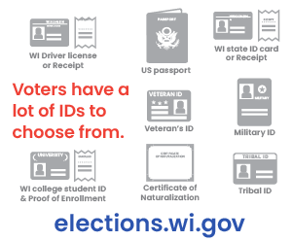
Absentee ballots | Use any time, preferably multiple times ahead of Election Day. | Returning Your Absentee Ballot? An absentee ballot must be placed in the mail, or the voter must personally deliver it to the municipal clerk at the clerk's office, designated alternate site, polling place, or central count location.  Voters who need assistance due to a disability can select someone to return the ballot.  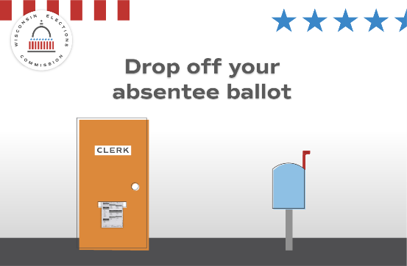
Disability rights | Use any time, preferably multiple times ahead of Election Day. | 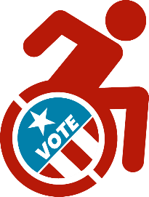  Voters with disabilities have options.  If you need help returning an absentee ballot, you can select a person to mail or deliver the ballot to the clerk’s office, other designated site, polling place, or central count location. You just can't select your employer or union.
Registration | Use before Feb. 17 | Are you prepared for the Feb. 21 Spring Primary?  You can register at your local clerk’s office until Feb. 17 or at the polls on Election Day.  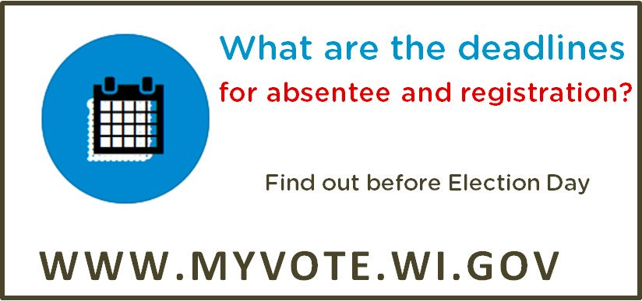

Photo ID | Use any time | Don’t have an ID for voting or docs like a birth certificate? Get a free ID using the DMV’s ID Petition Process http://bit.ly/3Dj48EQ  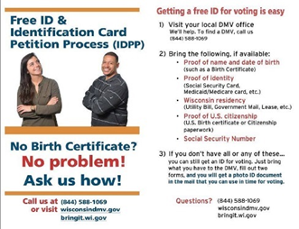
Absentee | Use any time on or before Feb. 14. | Finished filling out your absentee ballot? We recommend absentee ballots be mailed back to your municipal clerk by Feb. 14 to arrive on time.  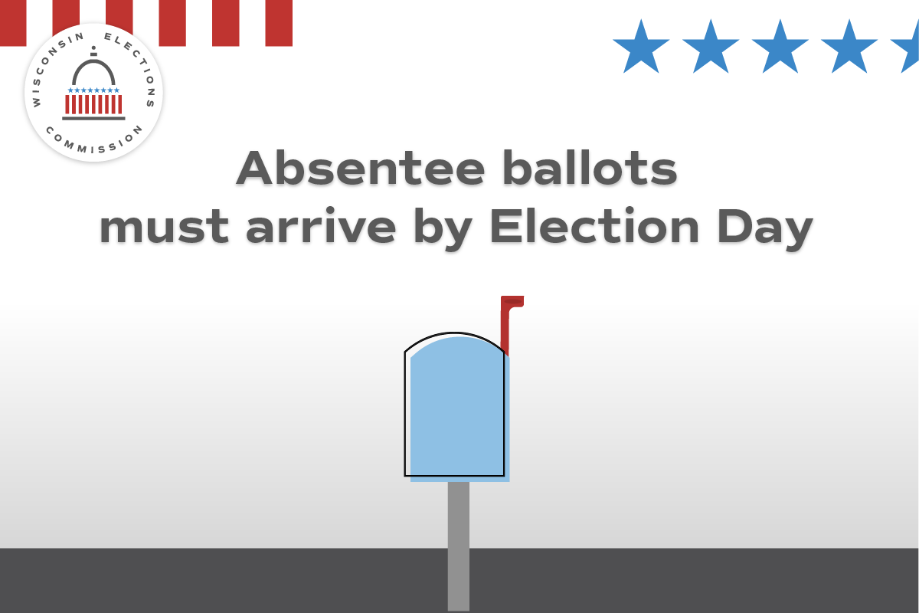
Absentee | Use on or before Feb. 16 | When voting absentee, pay close attention to the included instructions. Make sure your voter information is correct, that you've signed and your witness has provided their name and full address clearly on the return certificate envelope.  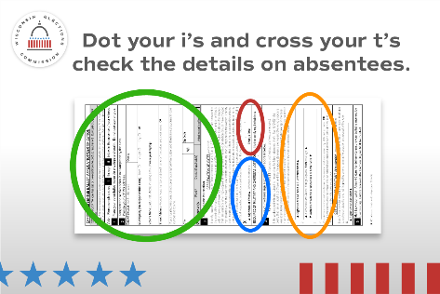
Registration | Use by Feb. 16 | Missed your chance to register to vote online or by mail? You can still register at your clerk’s office until Feb. 17 or at your polling place on Election Day.  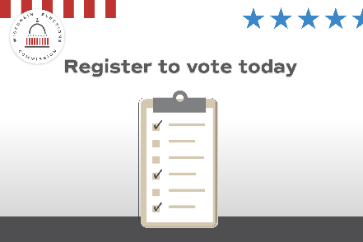

Registration | Use on or before Feb. 17 |  |  | Have you moved or changed your name? You’ll have to re-register to vote! You can still do so at your clerk’s office until Feb. 17 or at the polls on Election Day.  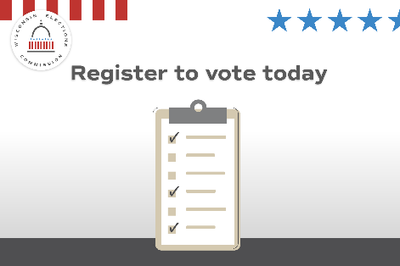
Witness | Use on or before Feb. 16 |  |  | Line up a witness before you vote absentee by mail. You’ll need their signature and full address. Learn more at http://bit.ly/3kJHv60  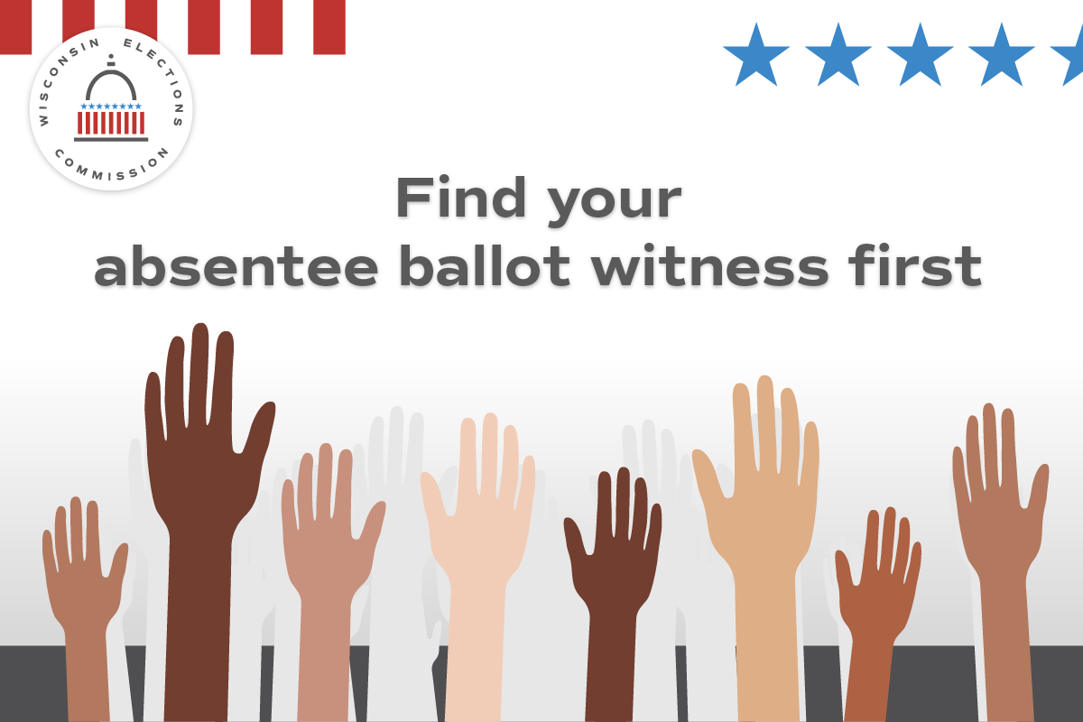
Absentee | Use by Feb. 14 |  |  | Mailing in your absentee ballot is easy. Just remember to do it early! Your ballot must arrive by Election Day to be counted.
Poll Worker Recruitment | Use and promote as needed |  |  | Want to help your community and get paid? Serve as a poll worker! Visit https://myvote.wi.gov/en-us/Become-PollWorker
Photo ID | Use any time |  |  | Your photo ID doesn’t need your current address. What ID will you use to vote at the polls on Feb. 21? http://bit.ly/3Dj48EQ  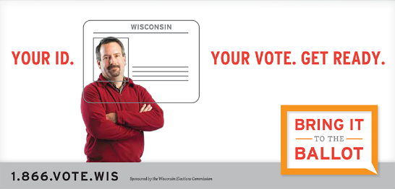
Security | Use any time |  |  | 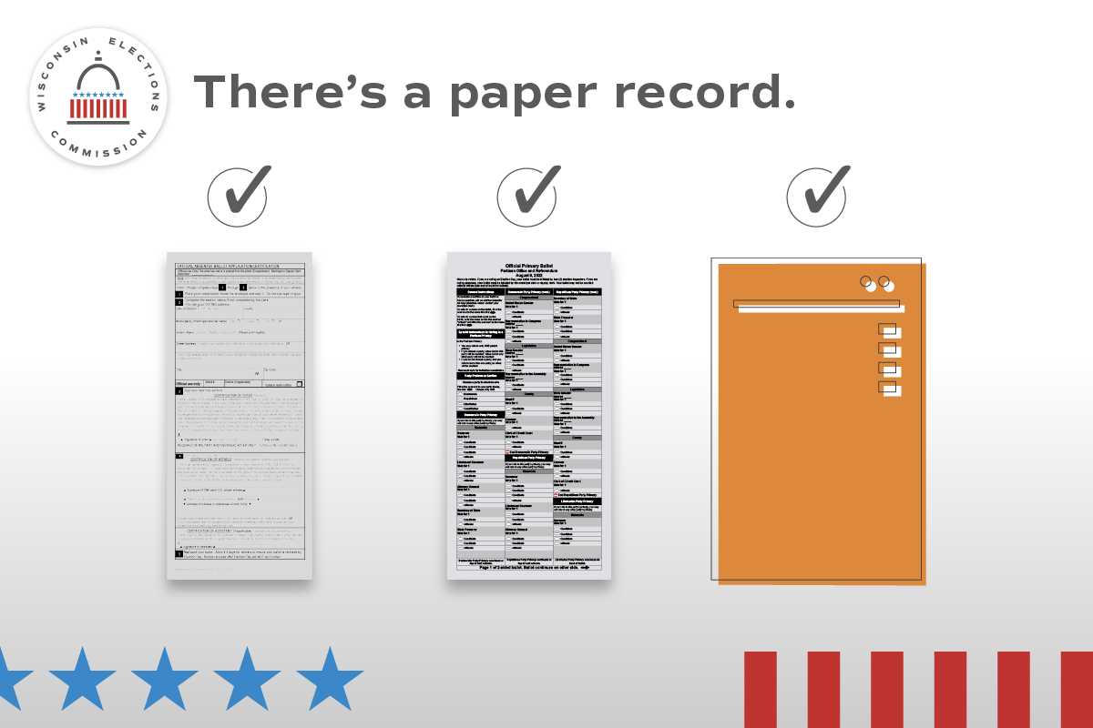  Every vote has a paper trail. Wisconsin requires a paper record of every vote that’s cast, no matter what kind of ballot or voting equipment used.
Absentee | Use on or before Feb. 16 |  |  | Voting in the Feb. 21 Spring Primary? Choose the option that’s right for you: vote at the polls, by in-person absentee ballot, or by mail absentee ballot.  MyVote.wi.gov  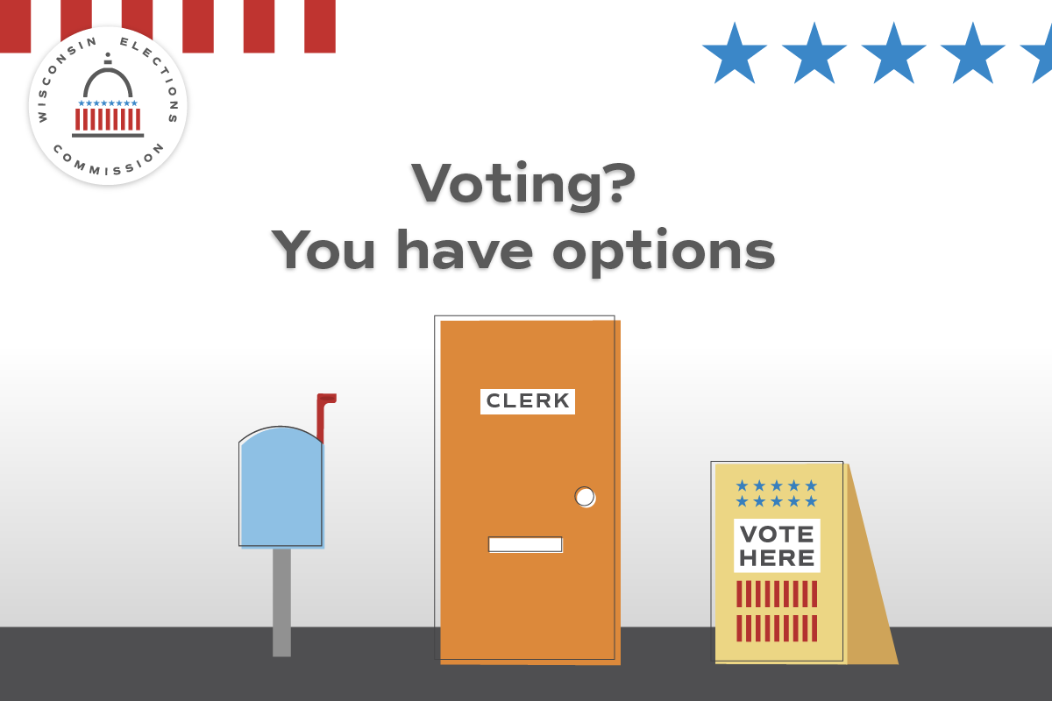
Security |  | Use any time, as frequently as you wish until and after Election Day. | There are multiple checks on Wisconsin elections to keep them secure and accurate.  Learn more at elections.wi.gov/101  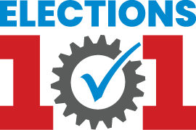
Photo ID |  | Use any time | Don’t forget to bring your photo ID to the polls on Feb. 21! Visit http://bit.ly/3Dj48EQ for more info about all the forms of ID accepted for voting, including how to get a free ID!  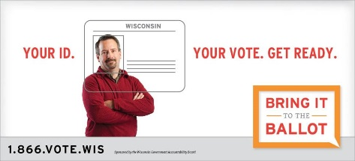

Absentee |  | Use by Feb. 14 | Finished filling out your absentee ballot? Don’t wait to mail it back or drop it off! All absentee ballots must arrive by Feb. 21.
General Info |  | Use any time | Do you know where your polling place will be for the Feb. 21 Spring Primary? Confirm your polling place location at https://myvote.wi.gov/en-us/Find-My-Polling-Place
Absentee | Use before Feb. 14 |  | Finished filling out your absentee ballot? Don’t wait to mail it back! All absentee ballots must arrive by Feb. 21.  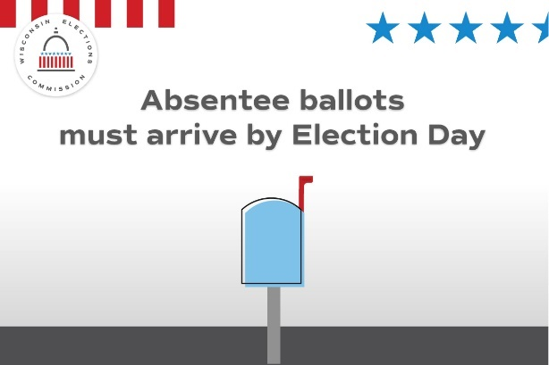
IPAV | Use by Feb. 19 or last day of in-person absentee voting offered in your community. |  | Cast your ballot before Election Day by voting an in-person absentee ballot at our office! Our hours are (INSERT HOURS OR BY APPOINTMENT INFO HERE).  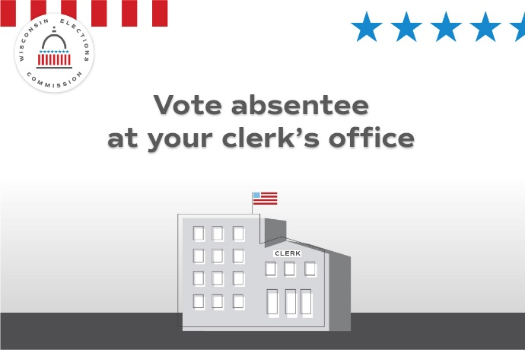

Absentee | Use any time | Haven’t returned your absentee ballot? You can still drop it off (INSERT DROP OFF LOCATIONS) on Election Day. All absentee ballots must arrive by Feb. 21.
General Info | Use any time | Get ready to vote on Feb. 21 by seeing what’s on your ballot. Visit MyVote.wi.gov for more information.
Social Media posts for use Feb. 21, Election Day
Focus of the day -- General election info.
Topic | Timing | Suggested copy and image
Election Day | Use only on Feb. 21 | It’s Election Day! All polling places will be open 7am-8pm. Find your polling place at MyVote.wi.gov  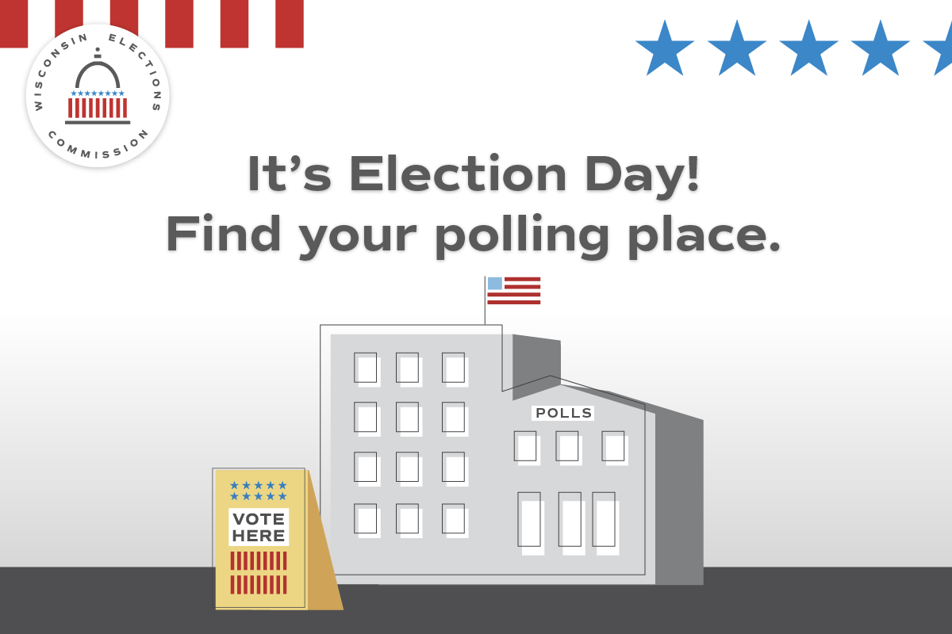
Election Day | Use only on Feb. 21 | Still have your absentee ballot? Drop it off at (INSERT DROP OFF LOCATIONS)!  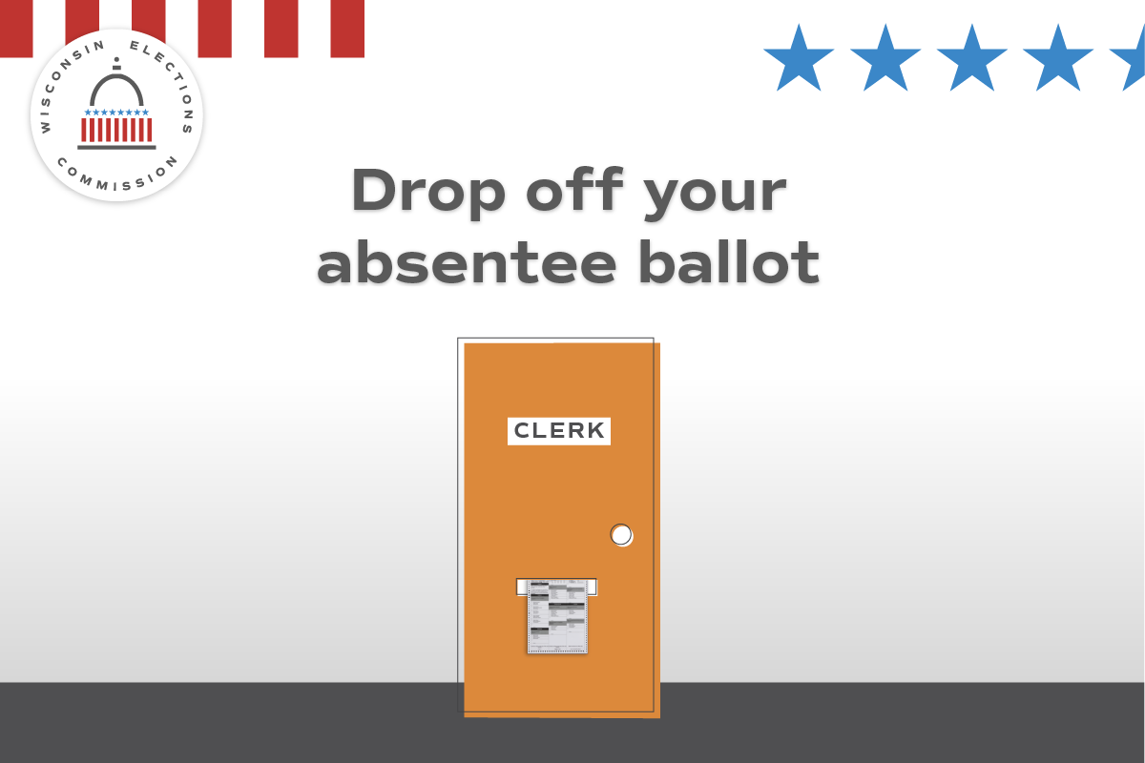
Security | Use only on Feb. 21 | In Wisconsin, election results aren’t official until they’ve been reviewed at the local level, double-checked by county officials, and certified by the state. Find out how Wisconsin delivers election results you can count on at http://bit.ly/3HyVwfD  