Mail Merge Instructions – Indefinitely Confined Voter Letter
Mail-merge instructions are for Microsoft Word documents only
Advanced Find Instructions
- Open the Advanced Find feature, click the filter icon in the upper right-hand corner of the WisVote ribbon and next to jurisdiction information.

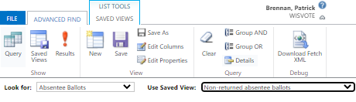
- Click the dropdown in the Look for field and choose Absentee Ballots
- Click the dropdown in the Use Saved View field and choose Non-returned Absentee Ballots
3

2

- Click the red Results button
1

*Advanced find results will populate, if any records meet the criteria
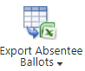
- Export the absentee ballot records
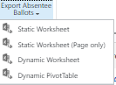
  - Click the Export Absentee Ballots icon
or
  - Click the dropdown under the Export Absentee Ballots icon and choose Static Worksheet
- Review the spreadsheet and remove any records that do not need a letter
- Save a copy to your computer. Make note of where the file is saved
Mail Merge instructions
- Open the template letter Microsoft Word.
- Fill in your municipal address, phone number, and email address in the highlighted sections.
- Remove the highlighting from the updated fields
- Select the Mailings tab
  - Click Select Recipients
  - Choose Use an Existing List from the dropdown menu.
1
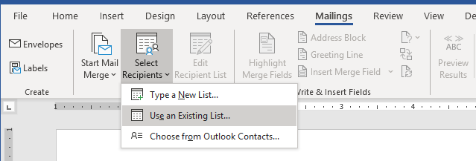
2

3

- Your computer file menu will pop up on the screen.
  - Navigate to the folder where the spreadsheet was previously saved
  - Choose the saved spreadsheet
- Once selected, the default table will be Absentee Ballot Advance F###$. Confirm the First row of data contains column headers option is checked. Select OK.
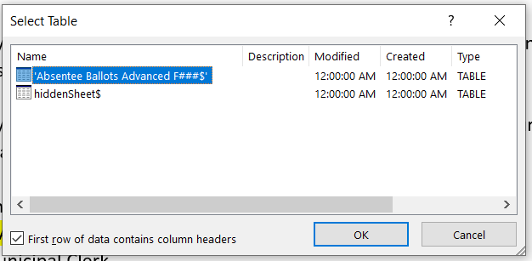

- While still on the Mailings tab, click Finish & Merge and then choose Edit Individual Documents.
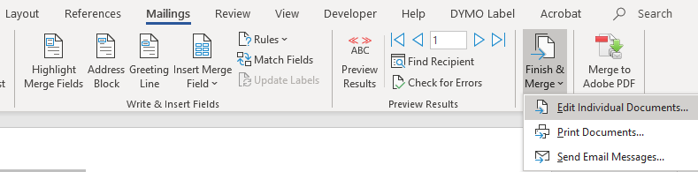
- Confirm All is selected and press OK.
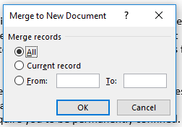
- Review the generated letters and make any edits
- The letters are now ready to be printed directly or saved and printed later.

